

SELF HELP GUIDE
As an organisation we wanted to give you self care ideas and easy step by step guides to help you cope with the feelings you may be experiencing during the Coronavirus outbreak. We have included grounding techniques, mindfulness tips, puzzles, colouring pictures and much more.
We hope this can help during your time staying home and is for young people and adults alike.

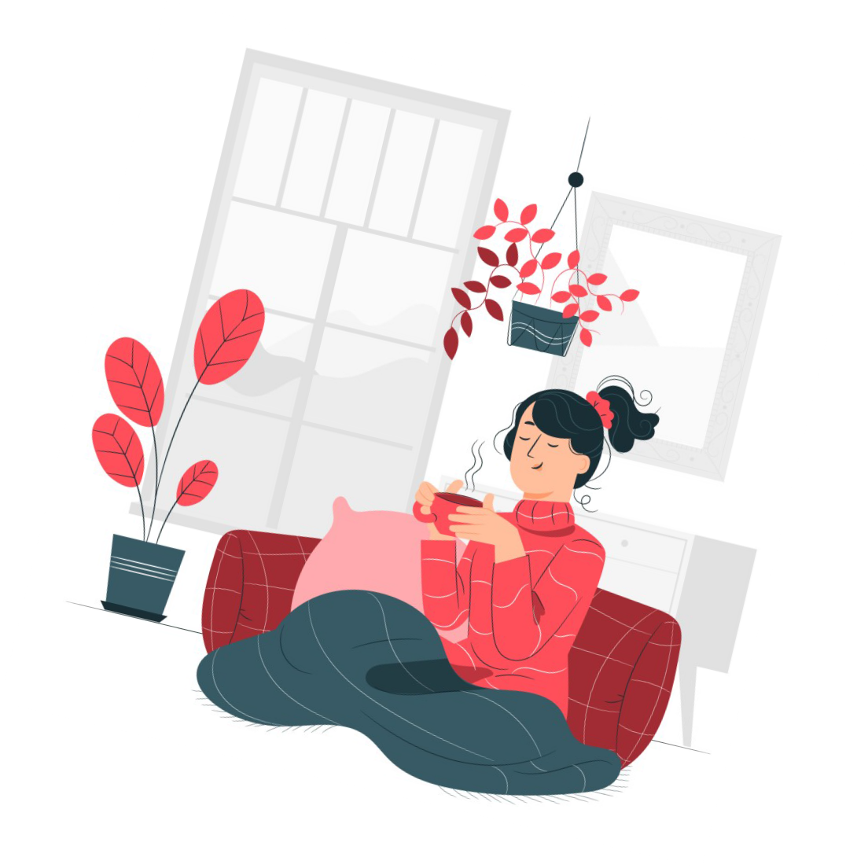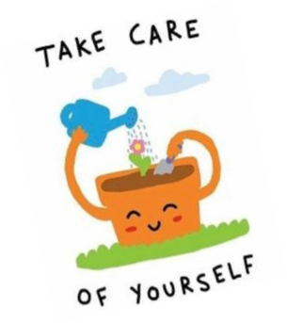

Please note, we do not own any pictures used in this pack.. The pictures used have been taken from online sources .

We know with staying at home means you have to make the most of what you have. This will probably mean you will be using your phones, tablets, laptops & computers a lot more! Here are some great (free and
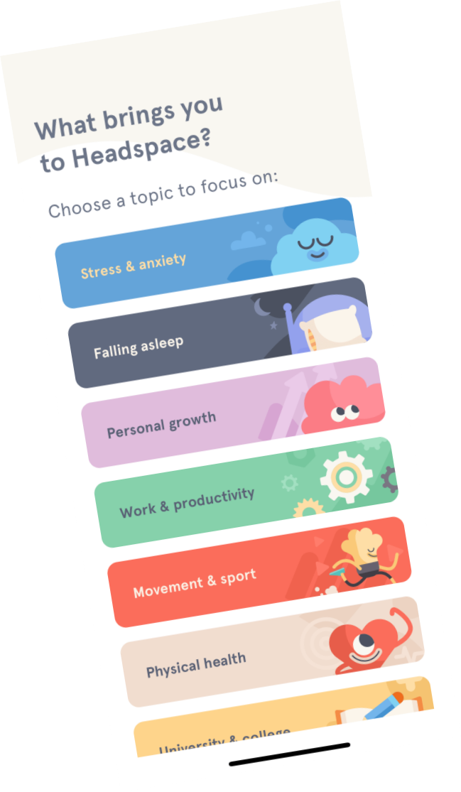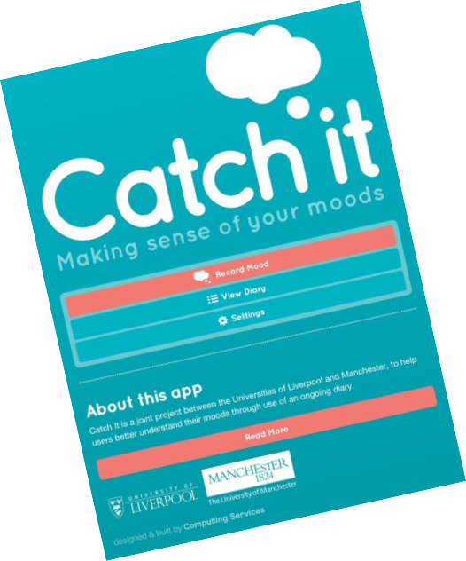paid) apps that you could use!

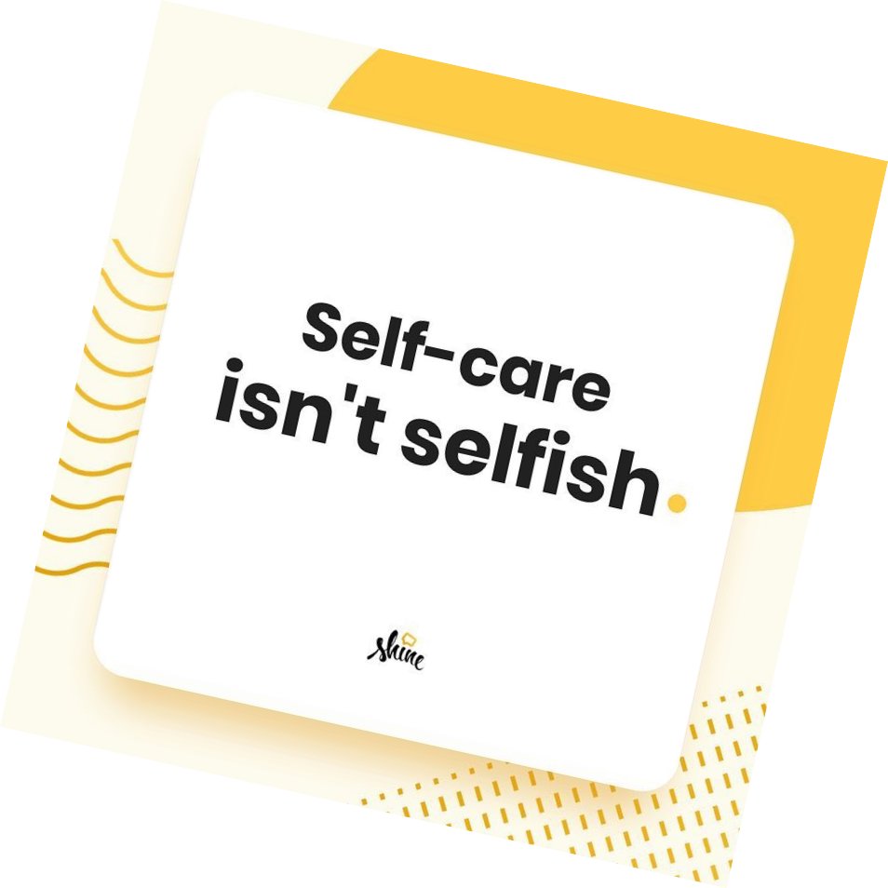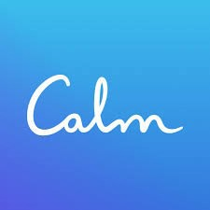HEADSPACE -There are loads of meditation and mindfulness techniques to use!

SHINE– This is a female focused self care app, ready with daily self motivational tips! It’s good to have a reminder of how great you are!

COLORFY- Colouring can be a relaxing experience, and a way to distract and occupy your mind.
Calm-This is a calming and relaxa- tion app. And its free. Focuses on improving your sleeping patterns, so if you are having trouble sleep- ing this might be worth trying
out!

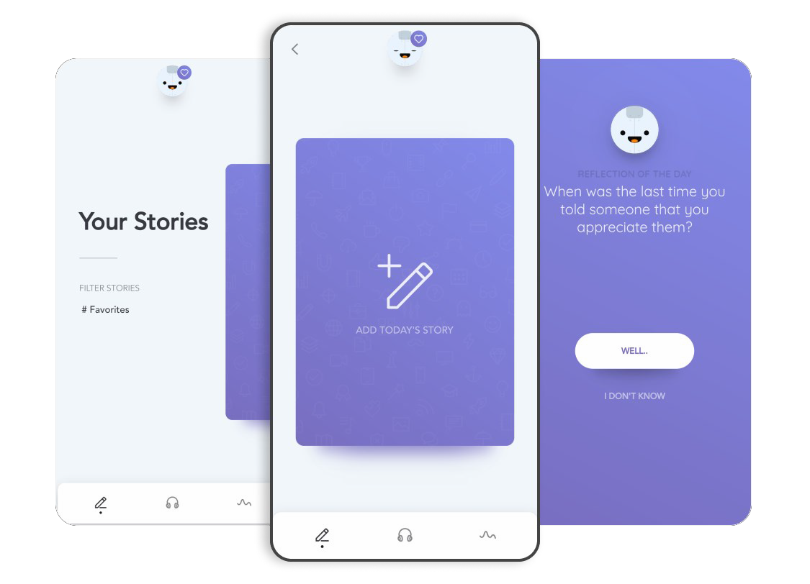REFLECTLY-Find it easier to write your feelings down? With this app you can keep a journal/diary.

CATCH IT– Aims to help you learn to manage your feelings, and make you look at a problem in a different way.

There is also our website where we have a number of self help guides aimed at helping with anxiety, self harm, anger, panic attacks and much more. Find out more– www.kcrasac.co.uk/our-services/self-help/

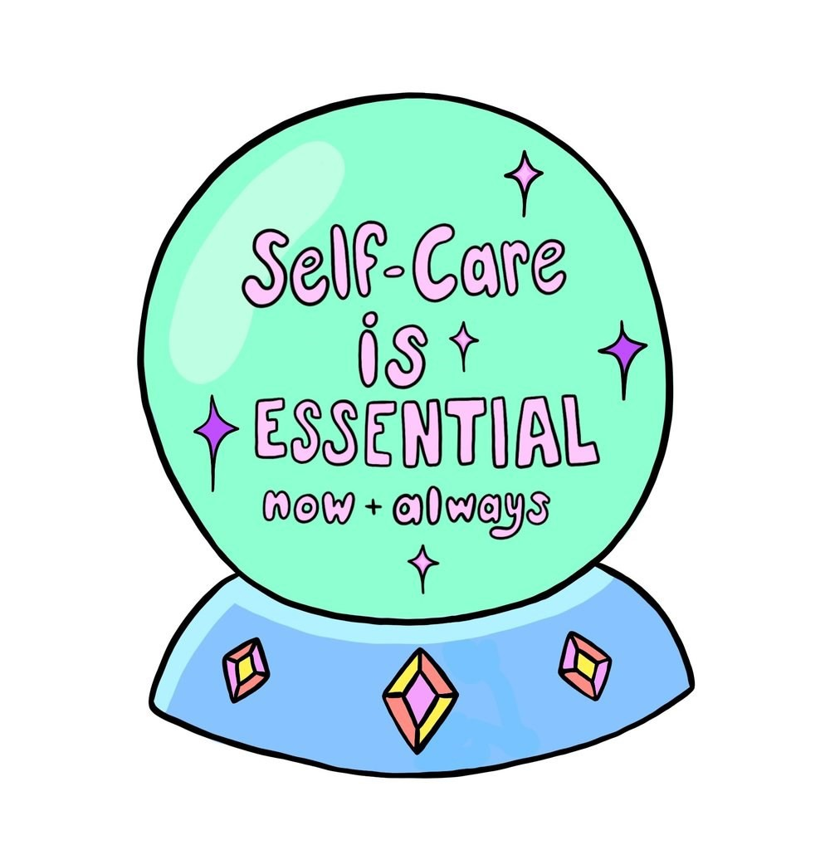MAKING A SELF CARE BOX
Self care is ever more important at this challenging time, but we know it can be difficult to get the time you need to fo- cus on yourself. However having a self care box with all of the items that will help calm, make you smile, laugh, remind you of how great you are, may make things easier!
Here’s a few tips on what you could put in a self care box….

COLOURING BOOK
YOUR JOURNAL/DIARY—Anywhere that you can write down your feelings, aims & goals
FAVOURITE BOOK
FAVOURITE PERFUME/BODY SPRAY
PICTURES– anything that puts a smile on your face!
LITTLE TREAT– such as your favourite snack TISSUES
COMFORTING PIECE OF CLOTHING– such as fluffy socks, favourite PJ’s or favourite blanket
TEDDY BEAR
MINI PAMPER SESSION– such as nail varnish , hand cream & face mask . Anything that is indul- gent

Personalise your box! For example; Stick pictures, se- quins, lights to it. You want it to be a happy space!
CANDLES ESSENCE OILS
MOTIVATIONAL AIDS/CARDS

Try Yoga or a meditation technique
Try something new! Such as having a different lunch, sitting at a different desk at work or changing your route home.
Might help to notice the world in a new way!
Notice when your mind wanders and try and bring it back
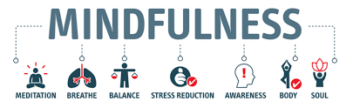
Mindfulness is about living in the moment and being fully present. Present in your body, mind and surroundings. Research has found that being mindful can relieve stress, improve sleep and reduce anxiety.

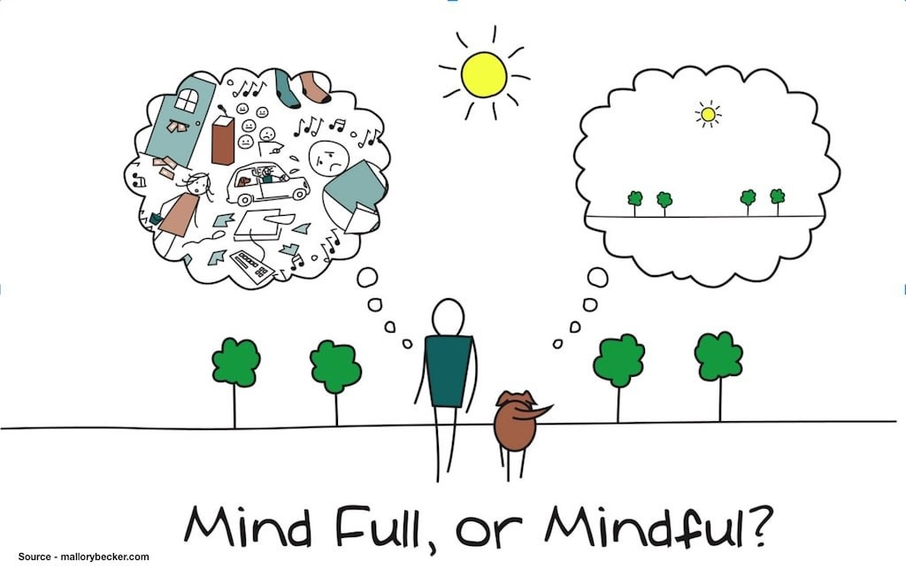Here are some ways that we can all add mindfulness in our daily lives. Lets try and change our minds from being ‘Full’ to ‘Mindful’……

Breathe
Accepting how you feel whatever that may be. Acceptance allows you to work through your feelings.

Learn a breathing technique for when you feel anxious

Take pictures– enjoy and be present in your surroundings
Try and do one thing at a time

Set time limits
Pay attention to your senses!

Go outside– whether that be to the local shop, walking the dog or standing in your garden!

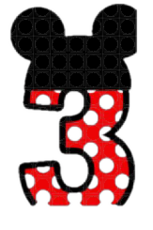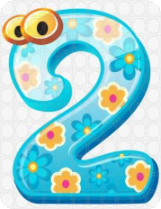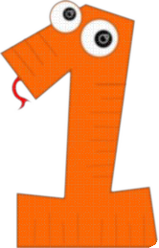Grounding
With your senses

Here is a quick tip on grounding yourself using all your 5 senses… wherever you are!

Just follow this easy guide to ground yourself.

Things you can see

Thing s you can feel

Things you can hear

Things you can smell

Thing you can taste

https://www.therapistaid.com/worksheets/groundin g-techniques.pdf

Breathing Exercise
Start at any “Breathe in” side, hold your breath at any point, then breathe out.

Keep going until you’ve gone around the whole star.

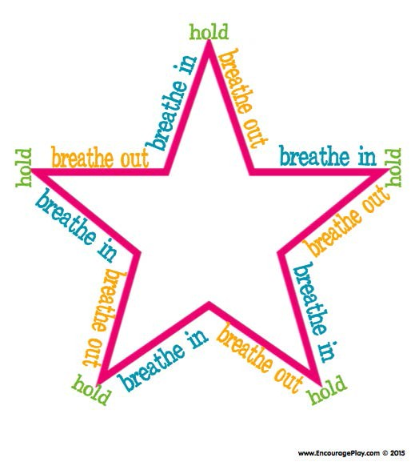


collarbone
- Under the arm
- Top of the head
Manage Anxiety,
depression and stress
Promote a deeper
mind-body connection
Reduce
Tension
Pain
Relief

Emotional freedom technique (EFT) is an alternative treatment for physical pain and emotional distress. It’s also referred to as tapping or psychological acupressure. EFT can help when feeling anxious or overwhelmed.

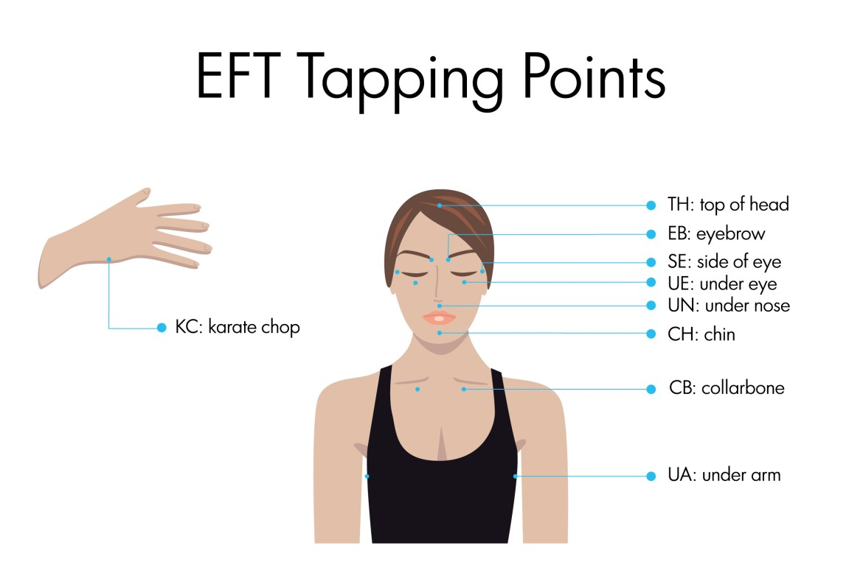Similar to acupuncture, EFT focuses on the meridian points — or energy hot spots — to restore balance to your body’s energy. Meridian points are thought of as areas of the body energy flows through. Acupuncture uses needles to apply pressure to these energy points. EFT uses fingertip tapping to apply pressure. EFT can help to restore balance to your bodies energy.
https://www.healthline.com/health/eft-tapping

Tap each point seven times, moving down the body in this order

- Karate Chop
- Eyebrow
- Side of the eye
- Under the eye
- Under the nose
- Chin
- Beginning of the

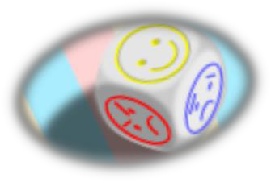Feelings journal…
Date;

What have I felt today / this week?

What has been positive for me today / this week?

What has made me happy today / this week?

A summary of the day / week…

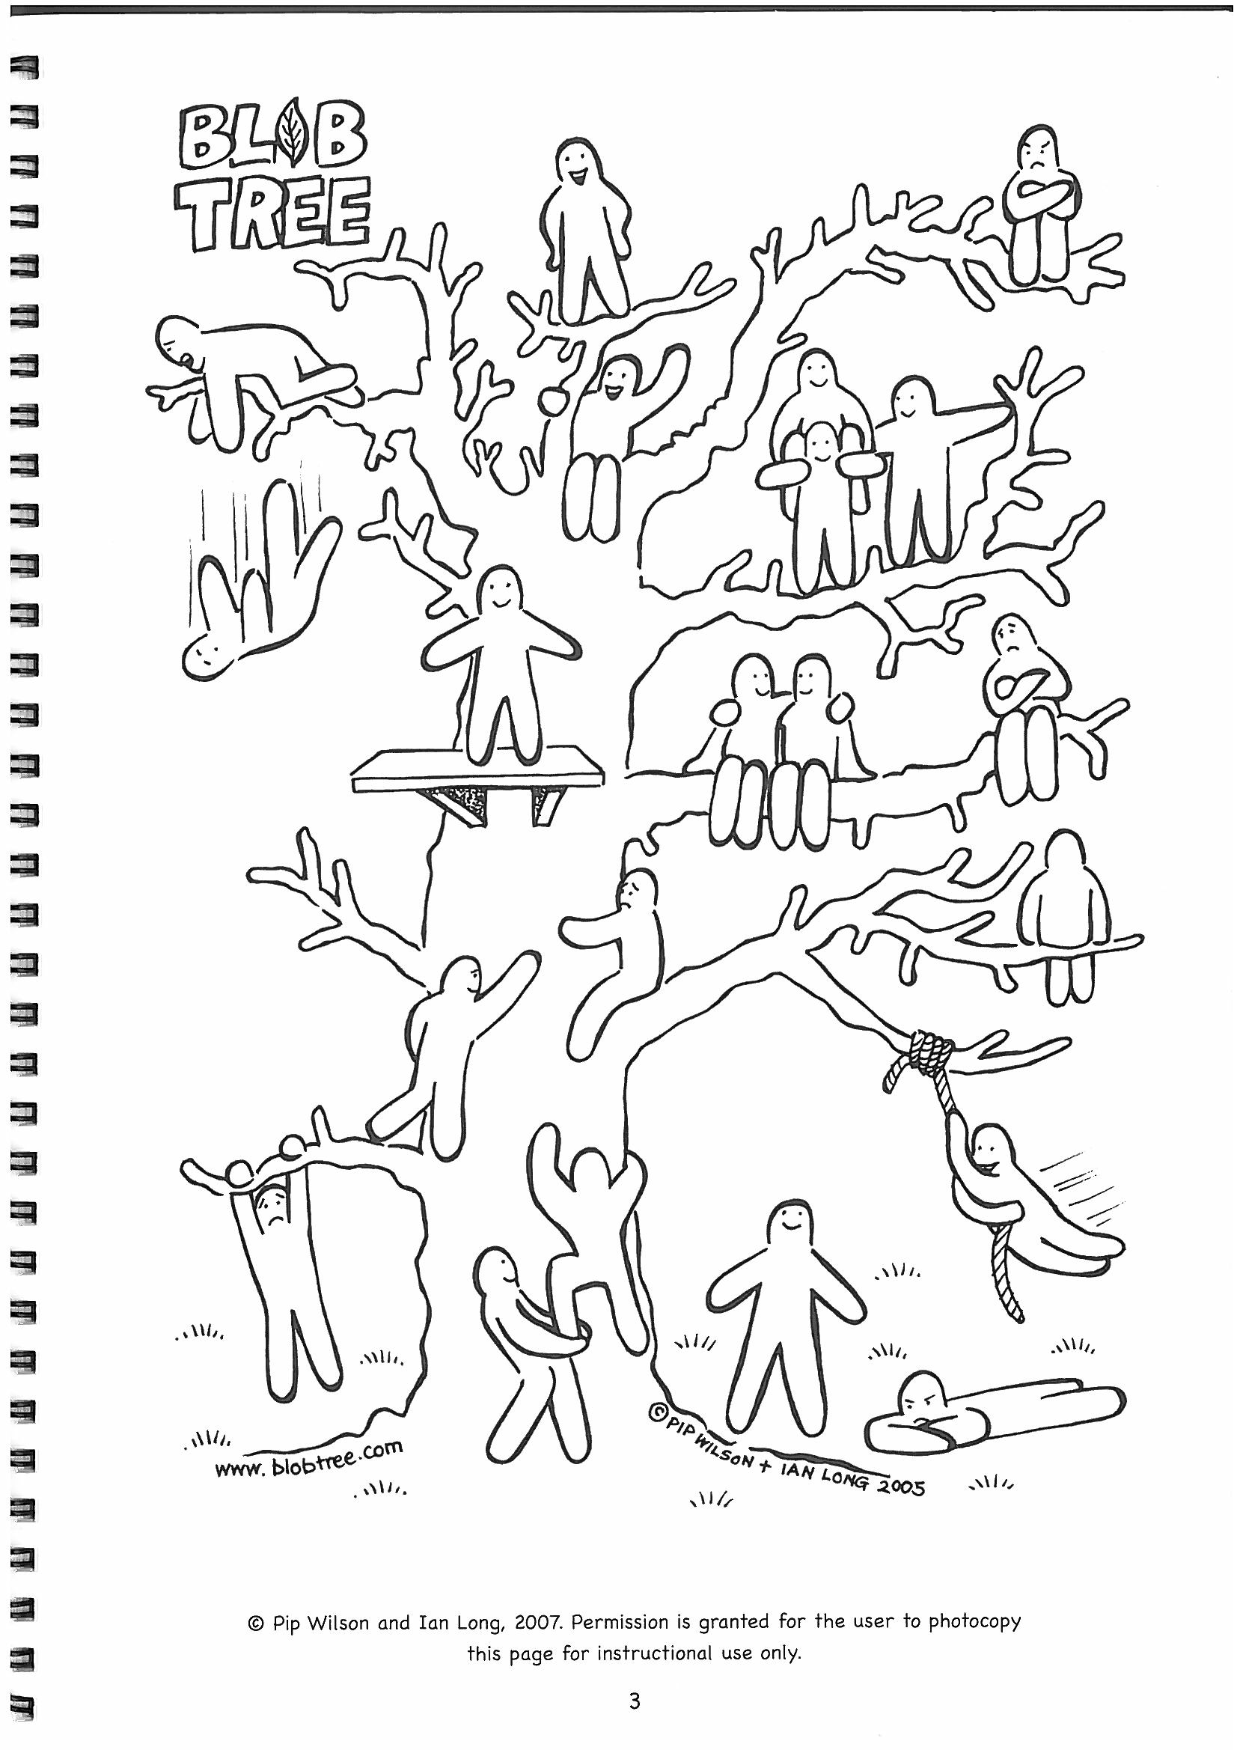Why not try and colour in how you're feeling today / this week and how you want to feel for tomorrow / next week?

Purple for today / this week

Green for tomorrow / next week

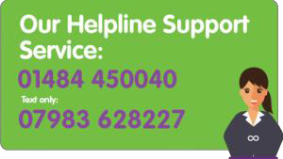
https://www.kcrasac.co.uk/

Current covid-19 number; 07903633909
Here you will find
some helpful numbers and links…
https://www.kcrasac.co.uk/
https://rapecrisis.org.uk/get-help/

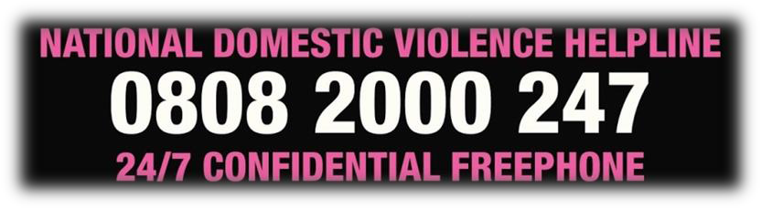

https://www.nationaldahelpline.org.uk/
https://www.kcrasac.co.uk/

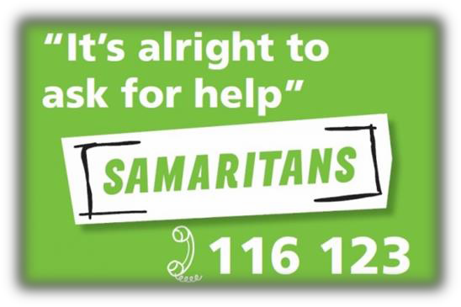https://www.samaritans.org/

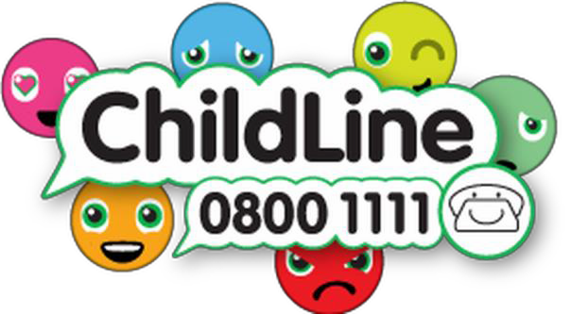
https://www.childline.org.uk/

https://www.twinkl.co.uk/


http://www.ichild.co.uk/

Here are some educational links and helplines for young people and children

https://www.topmarks.co.uk/ https://www.primarygames.com/
https://www.sparklebox.co.uk/

https://www.senteacher.org/

Something to pass your time .....

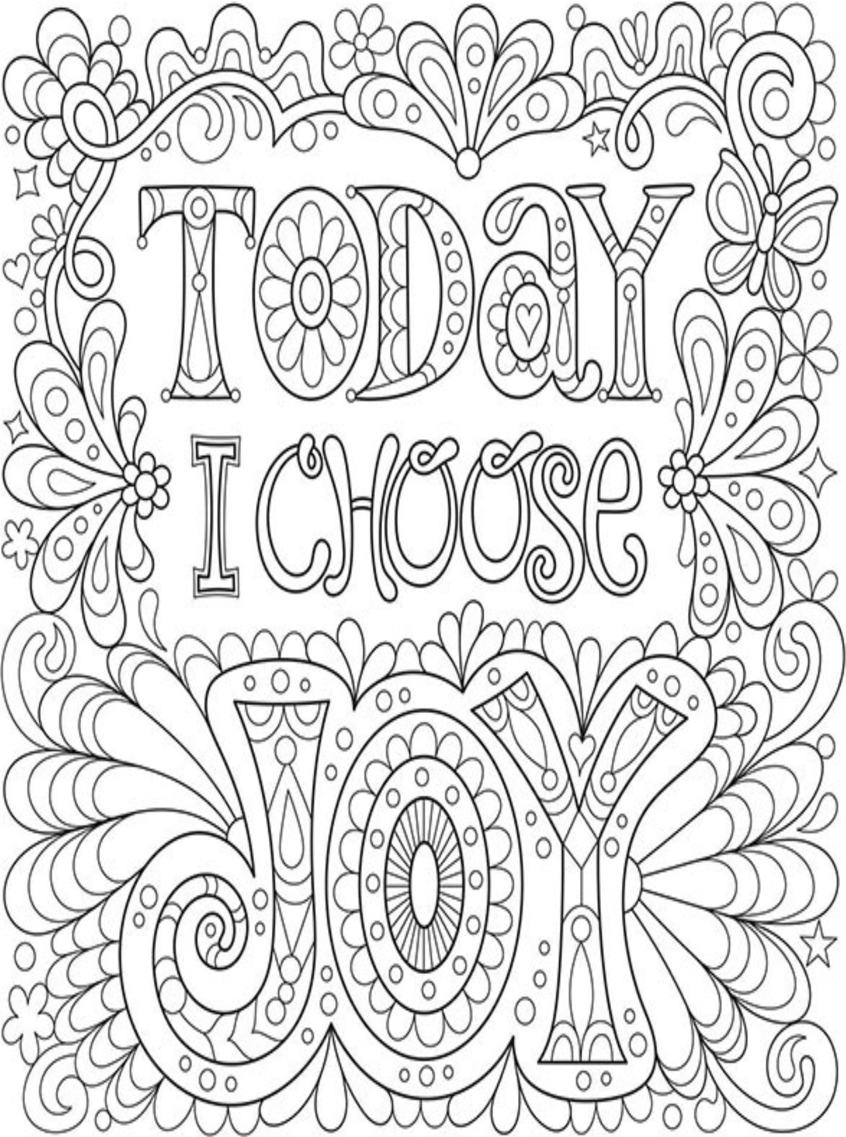

https:Uwww. a rt-is-f un.com /free-ad ult-coloring-pages

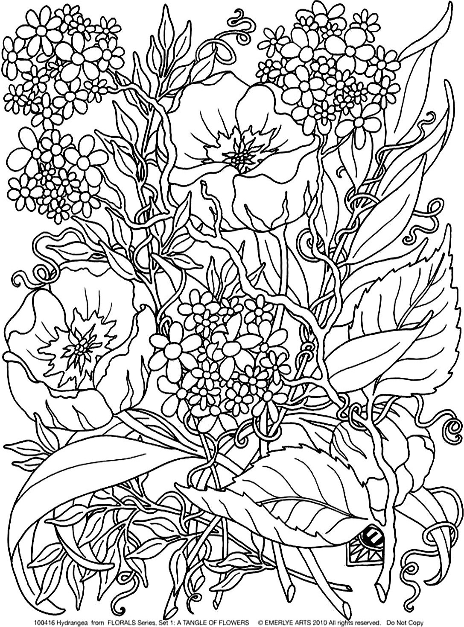

https://www. justcolor. net/nature/coloring-flowers/?i mage=fleurs-et-vegetation coloring-aduIt-savage-flowers 1

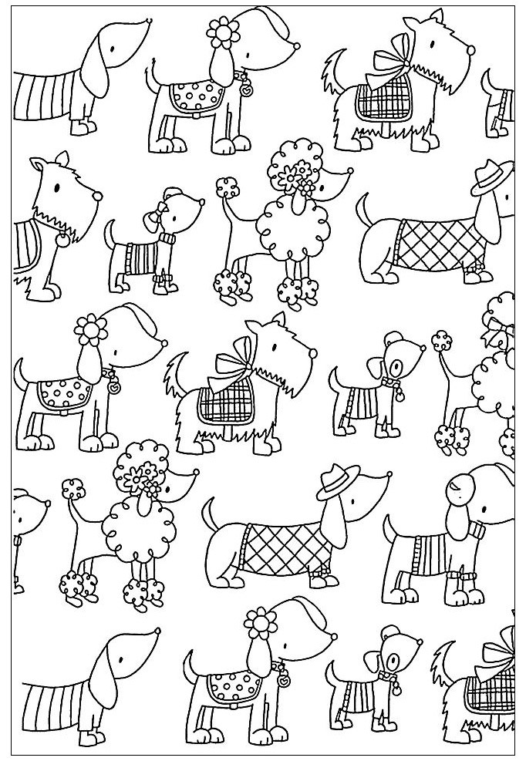

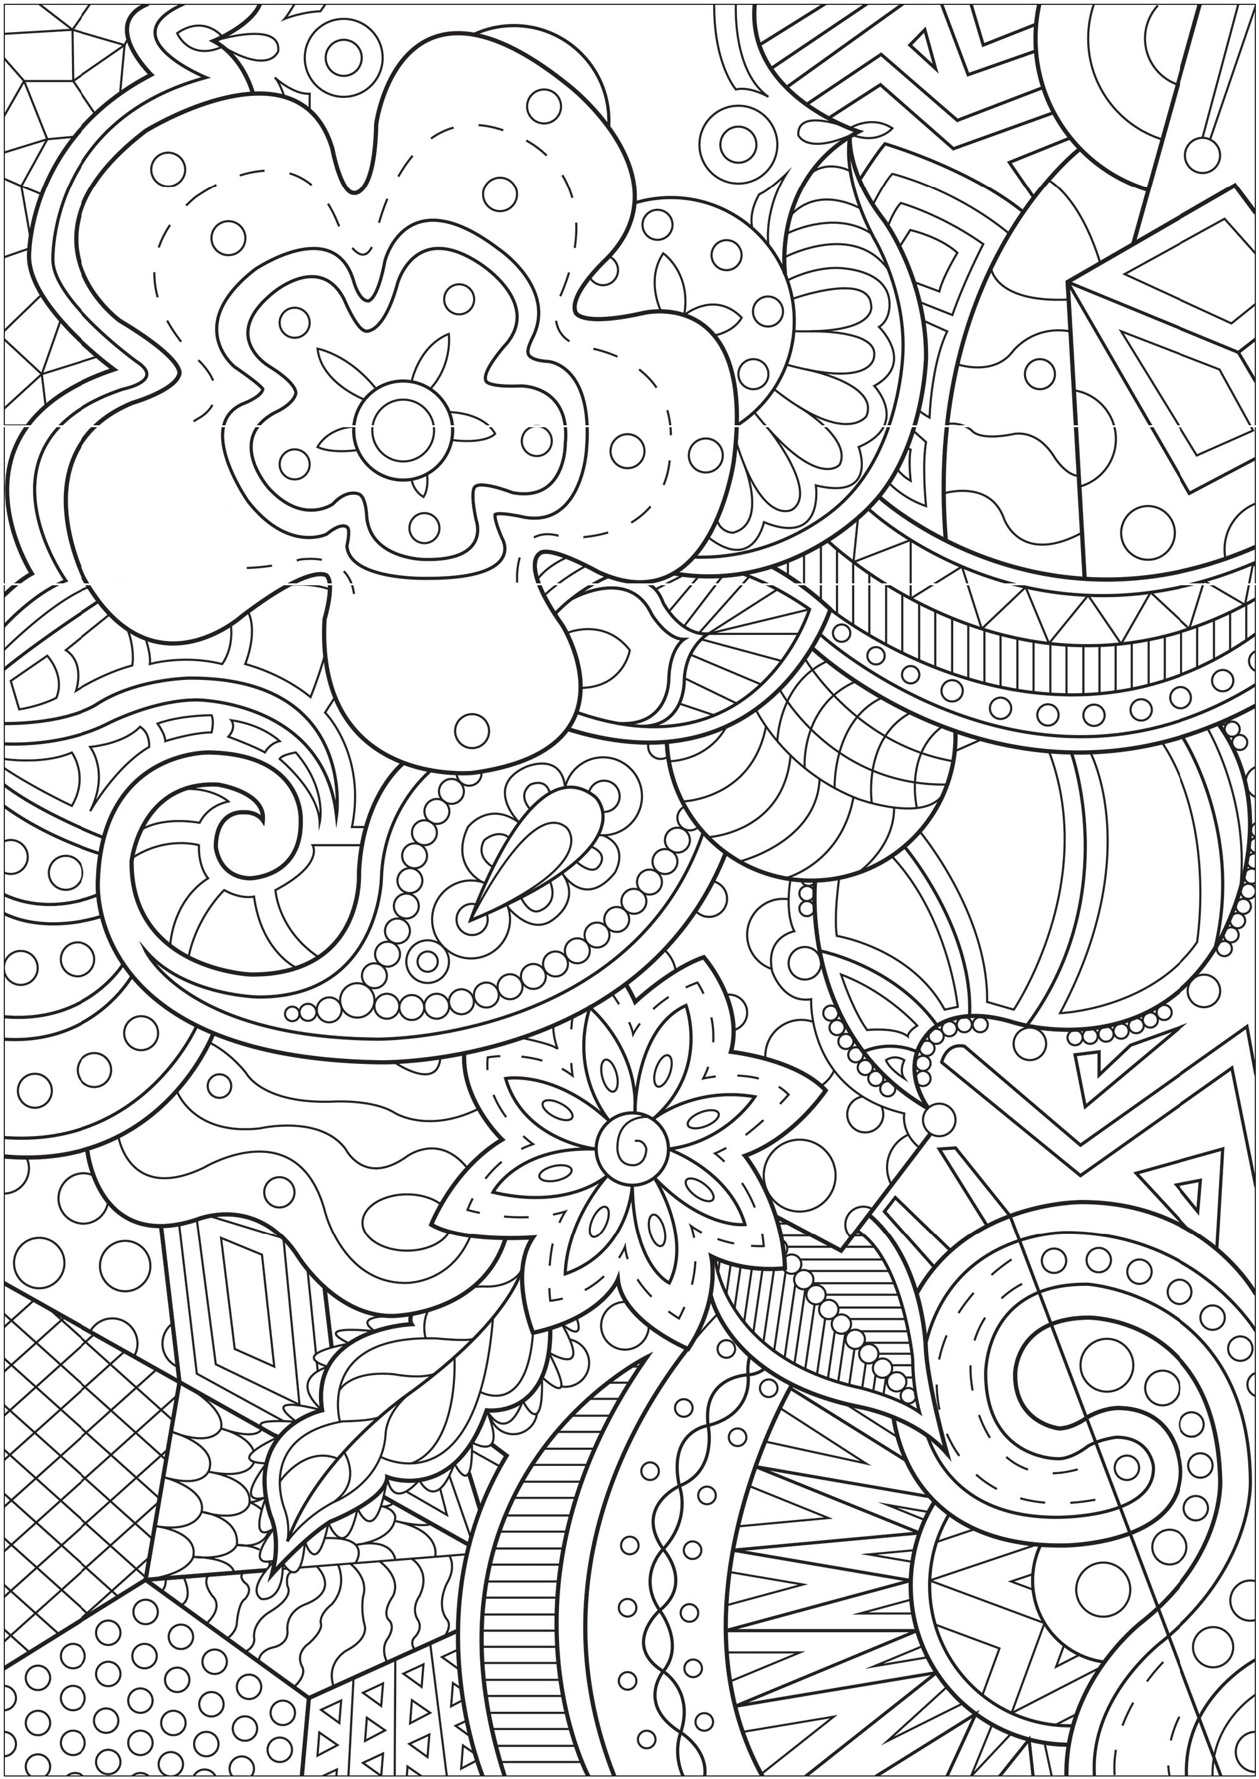/
' o
'\.
0 - - - \

\ 0 I
" /

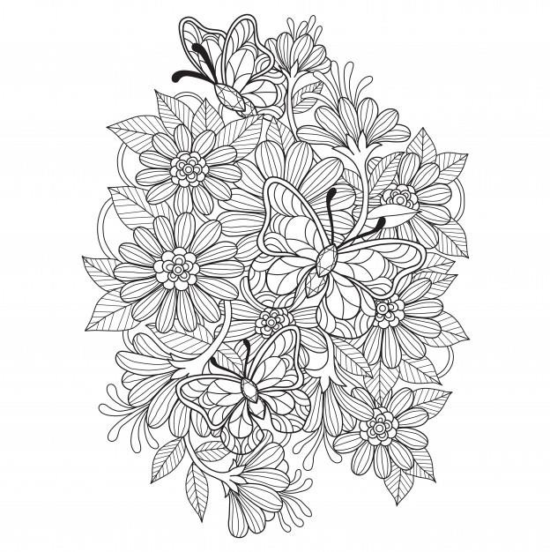

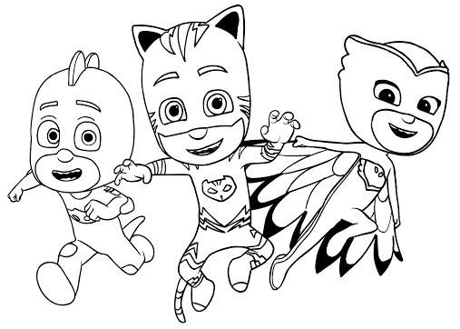

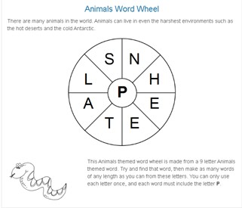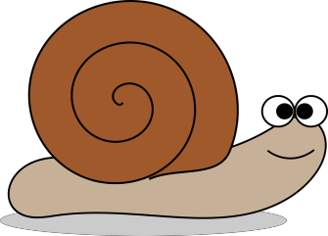
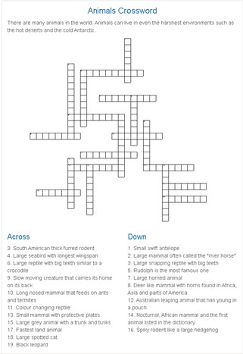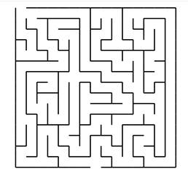



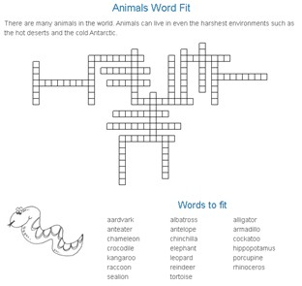To play more puzzles online visit
https://
fr eepr inta blepuz zles. c o. uk/

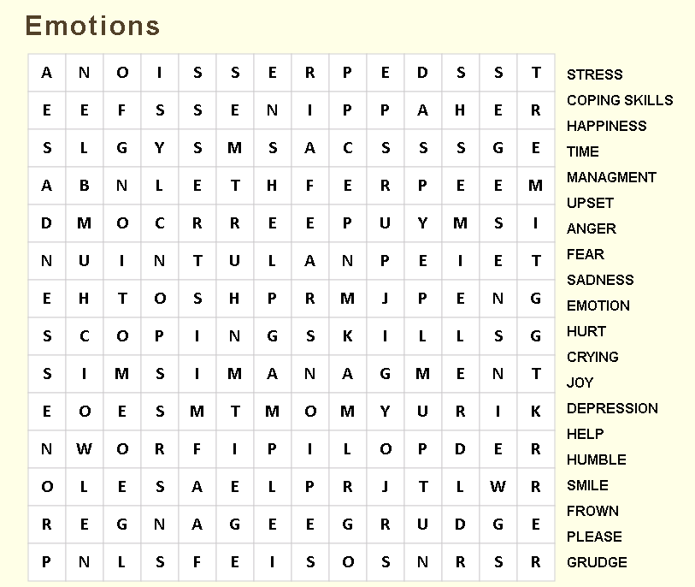
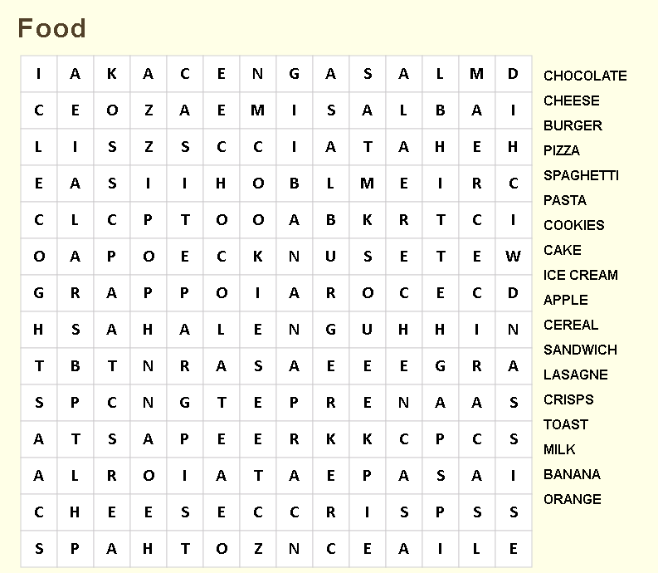
To play these wordsearches online go to https://thewordsearch.com/
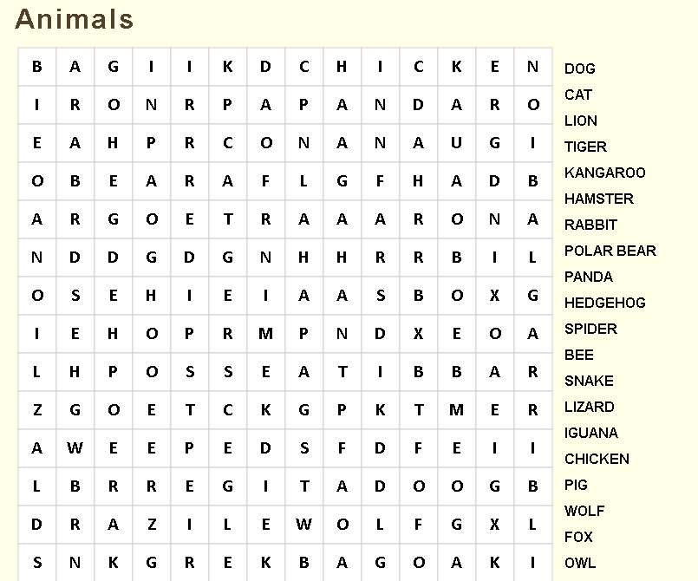
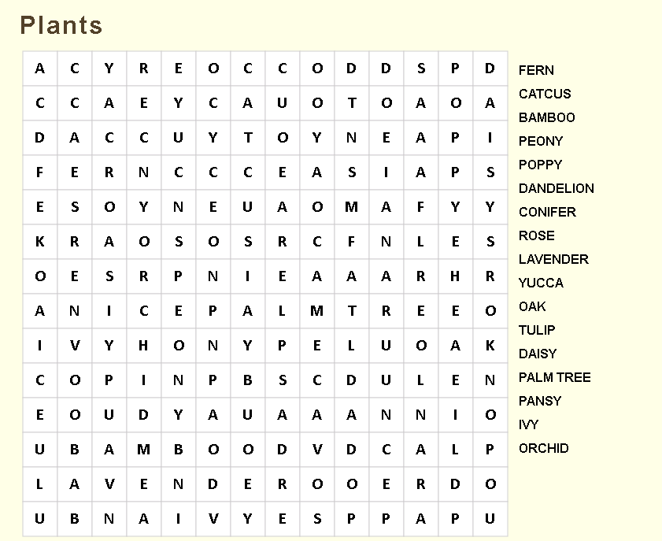
To play these wordsearches online go to https://thewordsearch.com/

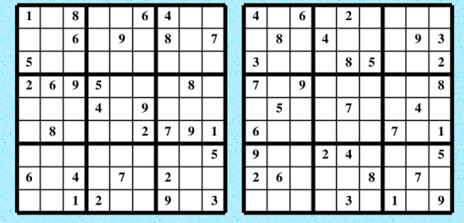
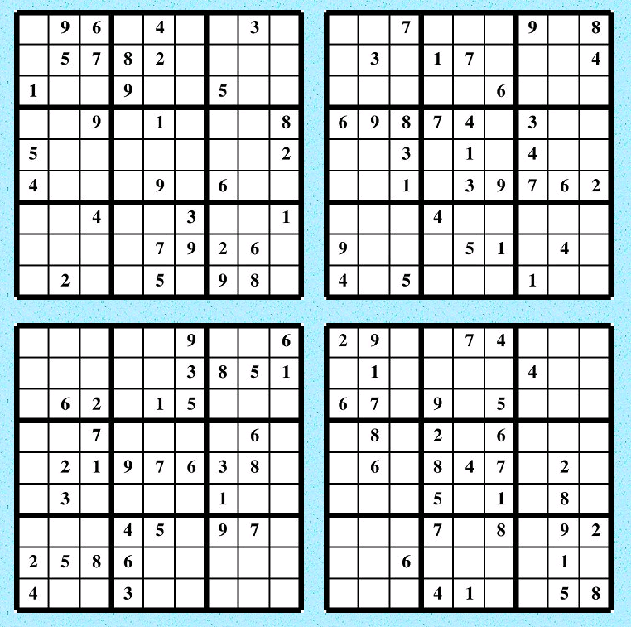
To play more sudokus online go to https://www.memory-improvement-tips.com/printable-sudoku-puzzles.html
To play more sudokus online go to https://www.memory-improvement-tips.com/printable-sudoku-puzzles.html
To play more sudokus online go to https://www.memory-improvement-tips.com/printable-sudoku-puzzles.html
To play more sudokus online go to https://www.memory-improvement-tips.com/printable-sudoku-puzzles.html
To play more sudokus online go to https://www.memory-improvement-tips.com/printable-sudoku-puzzles.html

