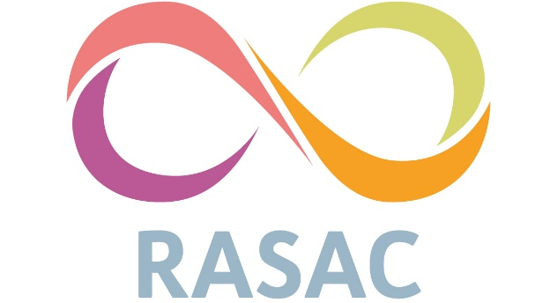

Confidentiality Policy

RASAC is committed to providing confidential information, support and therapeutic service to its users.
RASAC believes confidentiality is of paramount importance in all aspects of the work undertaken by any worker or volunteer involved in RASAC. The need to respect matters of confidence cannot be stressed enough. RASAC believes its users deserve the right to confidentiality; to protect their interests and confidentiality is essential to safeguard the interests of RASAC itself.
Any person involved in the work of RASAC in any capacity is in a position of trust and this trust must be always respected. Trust is a key factor when an individual contacts the organisation and discloses any information.
The guidelines relating to confidentiality at the Centre are equally important at all levels of involvement, whether trainee, paid worker, unpaid volunteer, trustee or worker attending the Centre.
RASAC offers a non-judgemental, free confidential service. Strict confidentiality about individual service users, workers and volunteers apply as laid down in this policy.
Service Users
In line with common law, the information shared between workers, volunteers and service users is confidential and should not be shared with any third party outside of RASAC without written authorisation. It is recognised however, that relevant matters concerning service users will be discussed internally with other workers or volunteers. Confidentiality is between the service users and the service, not between the service user and the individual worker or volunteer. Such discussions should only be conducted on a 'need to know' basis, and service user details and anonymity should be maintained. External persons who may be involved within the service must adhere to the principles of this policy and will be required to sign the confidentiality statement.
No formal written records of service contact by individuals will be kept, but brief initial telephone information, correspondence and a contact log will be used, and these details will be kept at the centre only for contact purposes, stored in a secure place (see GDPR policy).
Breaching Confidentiality
Confidentiality can only be breached under specific circumstances as follows:
- If a client discloses information about a terrorist plan, we are legally required to disclose to the police
- If a client indicates risk of serious harm to themselves e.g. suicidal intent, then appropriate risk assessment must be undertaken and where necessary confidentiality breached under our duty of care to service users
- If a client informs you of their decision to harm or seriously injure another person, this must be disclosed to the police
- At items 2 and 3 this may include where there are current drug trafficking offences
- If a client discloses of known on-going abuse of a named child or vulnerable adult, we must encourage them to disclose, if they will not, we must do so
When survivor information is discussed within the RASAC organisation it should be done with respect and sensitivity where appropriate.

Any circumstances where confidentiality may be breached must be taken to the safeguarding lead and senior manager before any disclosure is made (See Safeguarding Policy and Procedures).
RASAC Workers and Volunteers
Disclosures of information on any, staff member (volunteer or worker) to any third party outside of RASAC can only take place with written authorisation of the worker concerned. This includes addresses or telephone numbers.
The location and address of the centre will be kept confidential unless a volunteer or worker is arranging a meeting with a service user and the PO Box number must be used for all correspondence.
Confidential notes sent by email to any third party must have the express agreement of the person to whom the notes relate and should be sent as a password protected document or secure email.
During training all trainees will be asked to sign a declaration which states that they agree to abide by KCRASAC’s confidentiality policy for the duration of the training. On completion of their training all new volunteers and workers will be asked to sign a further declaration which amongst other points states that they will continue to respect and abide by the confidentiality policy.
Any member of staff (worker or volunteer) who breaches this policy will be subject to disciplinary proceedings and may be asked to leave the organisation (See Disciplinary Procedure).
Please try to remember that trust and confidentiality are key factors in the smooth running of RASAC. Any breach of this policy will be taken seriously and acted upon accordingly.
I agree to abide by the above guidelines:
Signed
Date
Print Name
0

