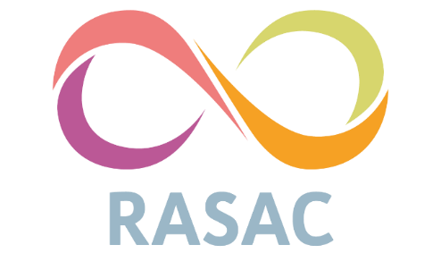

Equal Opportunities
Rape & Sexual Abuse Centre (RASAC) is an Equal Opportunities service in terms of both service provision and recruitment.
(Please also see RASAC’s Staff Recruitment, Anti-Racism and Anti-Oppression Policy)
This statement is about promoting positive attitudes towards equality and diversity and to ensure that everyone working at RASAC or receiving a service from RASAC are treated with dignity and respect in line with legislation under the Equality Act 2010, which brings together the numerous arrays of Acts and Regulations, which formed the basis of Anti Discrimination law in the UK prior to it and legislates against:
- Direct discrimination (someone is treated less favourably than another person due to having a protected characteristic or is perceived to have a protected characteristic)

- Associative discrimination (direct discrimination against someone because they associate with another person who possesses a protected characteristic or perceived to have a protected characteristic).

Protective characteristics are defined as:
- Age
- Disability
- Gender re-assignment
- Race
- Religion or belief
- Sexual orientation
- Marital status or Civil Partnership
- Pregnancy or maternity
- Sex Equality

As such RASAC will not discriminate directly or associatively on the grounds of any protected characteristic. RASAC will also ensure that it does not discriminate indirectly i.e. have a rule or policy that applies to everyone but disadvantages those with a particular protective characteristic.
RASAC is committed to ensuring equality of access both to the service and to opportunity and will make appropriate provision for all service users, workers and volunteers with special requirements in so far as facilities and resources will allow. This includes giving all employees and volunteers’ equal opportunity and access to training to enable them to progress both within and outside the organisation.
RASAC is committed to a programme of action to make this policy effective and will bring it to the attention of all workers and volunteers who should familiarise themselves with it.
Any worker, volunteer or service user who wishes to make a complaint about equality should refer to the Complaints Policy and Procedure.

