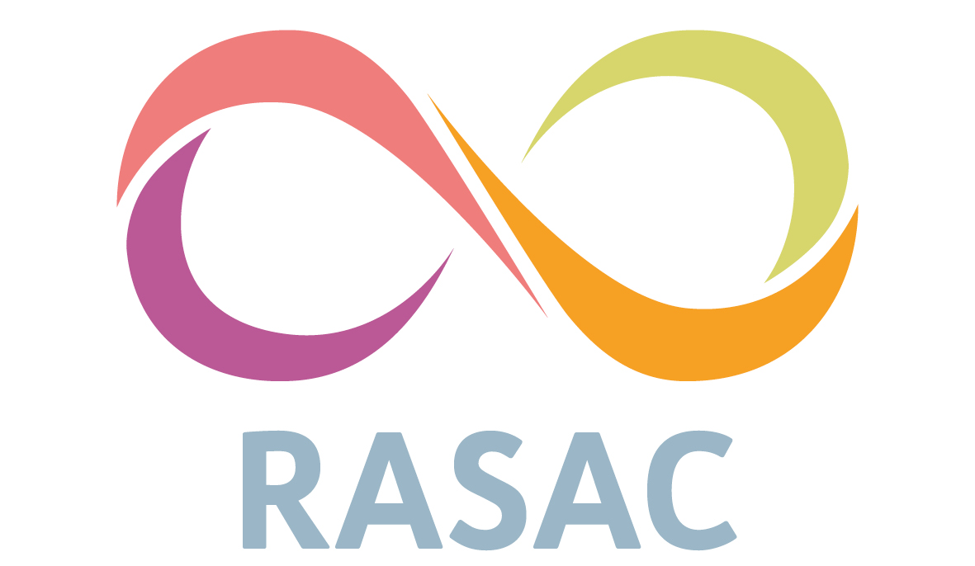

Service User Involvement Policy
The Rape & Sexual Abuse Centre (RASAC) is committed to ensuring progress towards meaningful service user involvement in all aspects of our work. This commitment requires all Board of Trustee Members, staff and volunteers to encourage and support service user involvement.
RASAC will work to empower all service users to both play an active role in their own care and to engage them in the development of our services.
Definitions
Service User is defined as anyone who is accessing the RASAC services.
Involvement refers to the active participation of service users in their care and/or in the planning, delivery and development of RASAC services.
The aims of user involvement are to consult service users and develop partnerships so that their needs, views and suggestions can inform decision-making about services.
Aims and Values
RASAC recognises that service user involvement is important because services that reflect and consider the experience, needs and wishes of their users are more likely to be effective in promoting better mental health and recovery for those users; and that service users are the best or right persons to determine how those needs should be met.
The purpose of this policy is to ensure there is a consistent approach to user involvement across RASAC and to enable service users to have a key role in the service whilst making user involvement an integral component of organisational activity.
In addition to supporting organisational values and objectives the policy aims to build on local experience and national evidence that demonstrates that genuine user involvement can positively promote the self-esteem of those who take part, raise user expectations and promote partnerships to improve service quality.
Approach
RASAC is committed to offer opportunities for user involvement at all stages in a person’s contact with the organisation.
Users should have the opportunity:
- to be able to have a say in and make informed choices about the individual support they receive
- to have information available about their services and rights, including how to make complaints, confidentiality etc
- to be listened to by staff/volunteers
- to be supported by staff who work in an anti-discriminatory manner
- to have a say in and be able to influence RASAC service development, i.e. planning, delivery, monitoring, evaluation, training and recruitment of staff
User Involvement in Their Own Service
Individual support is planned in partnership with people who use our services.
To promote good practice staff must ensure that all users are:
- Involved in defining what they want out of the services they are offered at RASAC.
- Involved in regular reviews of therapy plans.
- Able to talk to someone other than their primary worker (initial assessment worker or counsellor) if they have a difficulty that cannot be resolved with the person concerned.
- Aware of the RASAC complaints procedures.
User Involvement in the Organisation
This section outlines areas for potential involvement. It may involve individual service users or groups such as service user forums. It is our goal to increase the range of opportunities for involvement further, for example:
- Where possible there should be user involvement in recruitment of RASAC staff. User representatives will be offered training, support and expenses to facilitate this process.

- RASAC will work with users to continually improve service quality by developing techniques to monitor the services provided e.g. questionnaires, interviews, suggestion boxes, exit interviews and discussion meetings/forums.

- Users should be supported to give direct feedback to the board of trustees and contribute to board governance activities and strategic planning events.
Supporting User Involvement
RASAC will continually need to monitor progress in user engagement including how we:
- Actively inform users about involvement opportunities.

- Support users to improve services at RASAC including offering access to internal or external training opportunities to support them to develop skills in user participation.
- Support service users who may become pressured or stressed through involvement activities, e.g. supervision.
- Ensure that all staff understand and support continuous improvement in user engagement.

- Ensure that the views of users are taken seriously and make a difference in the way that we deliver services.

- Ensure that feedback is given to users on how their views have made a difference.
Review
This policy will be reviewed every 3 years and further actions to progress the policy aims will be identified. Identified actions will become part of the organisation’s Business Planning objectives as appropriate.

