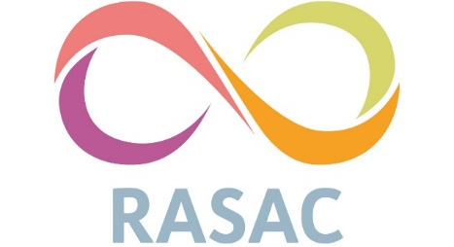

Safeguarding Children and Adults Policy and Procedures

1.0 Introduction and Purpose of the Policy

RASAC recognises that all children and adults, regardless of age, disability, gender reassignment, marriage and civil partnership, race and racial heritage, religion or belief, pregnancy and maternity, sex and sexual orientation, have the right to equal protection from all types of harm or abuse. This document sets out our policy and procedures regarding Child & Adult abuse whether the child, young person or adult at risk is the client of the service or is known to a client of the service.

The purpose of this policy is to provide staff and volunteers with guidance on procedures they should adopt in the event that they receive a disclosure or suspect that a child, young person or adult may be experiencing or be at risk of significant harm as outlined in the Children Act 1989 (updated 2002).

This policy applies to all staff, including the board of Trustees, paid staff, volunteers or anyone working on behalf of RASAC.

  - 1.1 Statement

RASAC exists to improve the lives of adults and children who have been affected by sexual violence. RASAC is fully committed to safeguarding the welfare of all at risk groups who either use our service or are in any way connected to people who do. RASAC recognises its responsibility to take all reasonable steps to promote safe practice and to protect service users from harm, abuse and exploitation in accordance with national legislation (Appendix 1). Workers will endeavour to work together to encourage the development of an ethos which embraces difference and diversity and respects the rights of children, young people and adults.

1.2 Organisational Commitment – RASAC will:

1.2.1 Make all staff aware of the present policy and ensure that all workers understand their responsibility to work to the standards and procedures detailed in the organisation’s Policies & Procedures

1.2.2 Ensure that all workers understand their legal and moral obligations to protect at risk groups from harm, abuse and exploitation.

1.2.3 Develop best practice in relation to the recruitment of all workers.

1.2.4 Ensure that all workers understand their obligations to report care or protection concerns about a child/young person/adult at risk, or a worker’s conduct towards a child and young person and adult at risk, to the organisation’s designated person for safeguarding or management

1.2.5 Ensure that all procedures relating to the conduct of workers are implemented in a consistent and equitable manner

1.2.6 Ensure that the designated person understands his/her responsibility to refer any safeguarding disclosures to the statutory safeguarding agencies (i.e. Police and/or Social Work)

1.2.7 Safeguarding training will be compulsory and delivered to all staff and volunteers as part of their initial and on-going training and provide opportunities for all workers to develop their skills and knowledge particularly in relation to the care and protection of children and young people and adults at risk

1.2.8 Ensure that children and young people and adults are enabled to express their ideas and views on a wide range of issues and will have access to the organisation’s Complaints Procedure

1.2.9 Ensure that parents/carers are supported and encouraged to be involved in the work of the organisation and, when requested, have access to all guidelines and procedures.

1.3.0 Endeavour to keep up to date with national developments relating to the care and protection of children and vulnerable adults

1.3.1 Respond swiftly and appropriately to concerns and disclosures.

1.3.2 We will provide regular high-quality supervision as a means of protecting at risk groups and take our time and seek support, using supervisors and respecting the concerns of the service-user to prevent disorganised action.

1.3.3 Maintain a culture where workers feel able to ask if they are not sure about a safeguarding issue, therefore protecting the needs and safety of all our service users.

1.3.4 Our disciplinary procedure will include steps for action if an allegation is made against a worker.

1.3.5 We have a whistle blowing policy in place so that staff and volunteers feel able to raise concerns that relate to the practice of RASAC or its representation

2.0 Child Protection Procedure (Service Users aged 18 and Under

2.1 General

2.2.1 When assessing referrals where the referrer is worried that a child may have been abused or neglected Children’s Social Care staff maintain a clear distinction between concerns that are ‘Section 17’ (safeguarding and promoting the welfare of children in need), possibly requiring family support, and those that are ‘Section 47’ (risk of significant harm), requiring the instigation of formal child protection enquiries.

2.2.2 If the service user tells us that a risk they have disclosed has already been reported to social care or police, the worker will check the details of the reported information with the relevant organisation to ensure protective steps have been taken.

2.2.3 Workers will not conduct home visits with children without parent/carer being present in the property.

2.2.4 Workers must not transport children under the age of 16 without an adult present in their car.

2.2.5 Workers are to help maintain strong links with other agencies to foster good practice and ensure that we have access to knowledge to adequately inform our service users.

2.2.6 Where a child is not accessing any education this will be reported to the Local Authority where the child lives.

2.3 Assessing competence to consent.

Use our current policy’s guidance on Gillick Competency.

2.4 Disclosure of Abuse or sexual exploitation (see appendix 3 and 4 for definition)

RASAC aims to balance the need to engage with and support young people whilst ensuring that they understand the limits to confidentiality and the circumstances in which information sharing would need to take place i.e. when there is a risk of significant harm. Information sharing will take place on a case-by-case discretionary basis following discussion with line managers.

2.4.1 All cases involving young people less than 18 years of age where police and social care involvement is not clear must be brought to the attention of the manager/s and discussed by the named worker for that client.

If there is a disclosure/suspicion of abuse (present/past or imminent)

2.4.2 In the first instance, if an allegation of abuse is disclosed to a worker, the worker will remind the child or young person of the safeguarding statement and advise them that they are obliged to report the danger (significant harm).

2.4.3 The worker should attempt to gain consent to disclose the information to an appropriate external body. However, the gaining of consent is not essential in order for information to be passed on.

2.4.4 The worker should inform the child/young person as best they can of the outcomes of disclosure to social care.

2.4.5 The worker should inform a manager on the same day.

2.4.6 The worker should make a written record of the allegation or suspicion of abuse in accordance with RASAC First Disclosures Procedure

2.4.7 All information is to be recorded on the RASAC incident reporting form to be filed in client case file once actions are complete and updated as necessary.

2.4.8 Parents should usually be informed of the concerns at an early point, unless there is an indication that they are complicit in the abuse, or to do so would place the child at risk of significant harm.

2.4.9 If it is decided necessary the worker will report the allegation/suspicion to Children’s Social Care and/or the police

2.5.0 After the disclosure has been reported, the worker should complete and submit a Safeguarding Incident Form and debrief with the manager/review the case as necessary.

2.5.1 The child should be supported and informed throughout this process in a sensitive and caring manner.

2.5 Disclosure, reporting and Information Sharing

Revealing the identity of a service user should only be done when they are at risk of significant harm (the legislative definition of harm is “any detrimental effect of a significant nature on the child's physical, psychological or emotional wellbeing”). The Children Act 1989 introduced the concept of significant harm as: ‘The threshold that justifies compulsory intervention in family life in the best interests of the child.’

2.5.1 Professionals concerned about potential conflicts of confidentiality between their duties towards children, should be guided by the principle that the welfare of the child must be paramount, and their primary responsibility must therefore be to share any information needed to safeguard the child

2.5.2 If there is any doubt about whether to report an issue to a manager, then it should be reported

2.5.3 In emergency situations (e.g. where there is the risk of severe physical injury), where immediate action is needed to safeguard the Health or Safety of the individual or anyone else who may be at risk, the emergency services must be contacted

2.5.4 Where a crime is taking place, has just occurred or is suspected, a manager should be informed, and the police must be contacted immediately on 999

2.5.6 Confidentiality must never be confused with ‘secrecy’. Informed consent should be obtained but if this is not possible and others are at risk, it may be necessary to override this requirement.

2.5.7 It is inappropriate for agencies to give assurances of absolute confidentiality in cases where there are concerns about abuse, particularly in situations when other people may be at risk

2.5.8 Further guidance, including “The Seven Golden Rules to Sharing Information”, can be found in Pan Cheshire Information Sharing Guide.
Children's Social Care - Referrals

Calderdale Children's Social Care | During office hours  Multi-agency Screening Team | Tel: 01422 393 336  E-mail: mastadmin@calderdale.gov.uk
Calderdale Children's Social Care | All other times, Emergency Duty Team | Tel: 01422 288 000
Kirklees Children's Social Care | During office hours  Kirklees Duty and Advice Team | Tel: 01484 414 960  (for members of the public) 01484 456 848
Kirklees Children's Social Care | At all other times, Emergency Duty Service | Tel: 01484 414 933
Wakefield Social Care Direct | Free and confidential phone line, open 24 hours a day | Tel: 0345 8503 503  E-mail: social_care_direct@wakefield.gov.uk
Emergency Duty Teams

Calderdale | Tel: 01422 288 000
Kirklees | Tel: 01484 414 933
Wakefield | Tel: 0345 8503 503
Safeguarding Children Partnership Managers

Calderdale Safeguarding Children Partnership Manager | Princess Buildings,  Princess Street,  Halifax,  HX1 1TS | Tel: 01422 394 098  E-mail: julia.caldwell@calderdale.gov.uk
Kirklees Safeguarding Children Partnership Manager | Mezzanine Floor  Brian Jackson House  2 New North Parade  Huddersfield  HD1 5JP | Tel: 01484 225 218  E-mail: KSCP.admin@kirklees.gov.uk
Wakefield Safeguarding Children Partnership Business Manager | County Hall,  Bond St,  Wakefield,  WF1 2QW | Tel: 01924 306 497  E-mail: wscp@wakefield.gov.uk
Local Authority Designated Officer (LADO)

Calderdale LADO | 2nd Floor  Princess Buildings  Halifax  HX1 1TS | Tel: 01422 394 086  Email: ladoadmin@calderdale.gov.uk  https://new.calderdale.gov.uk/council/data/protection-foi/privacy-notices-council-services/lado-service
Kirklees LADO |  | Tel: 01484 221126  LADO.cases@kirklees.gov.uk  https://www.kirklees.gov.uk/beta/working-with-children/lado.aspx  https://www.kirkleessafeguardingchildren.co.uk/safeguarding-2/safeguarding-processes-and-systems/lado-local-authority-designated-officer/
Wakefield LADO | Mark Wilkinson | Tel: 01977 727 032 Email:Lado.Referrals@wakefield.gov.uk  https://www.wakefieldscp.org.uk/professionals/managing-allegations-against-those-who-work-or-volunteer-with-children/

https://www.proceduresonline.com/LimitedCMS_centrally_managed_content/pancheshire/shared_files/info_sharing_guide.pdf

2.6 How to make a referral to Social Care:

Child protection referrals must be made as soon as abuse or neglect is suspected, by a telephone call or online referral to Children’s Social Care and must be followed up in writing within 48 hours on the agreed multi agency referral form (appendix 8). We work in 3 different local authorities with the process for each being slightly different so please follow the below information to refer a child to each district:

For anything further, visit: https://westyorkscb.proceduresonline.com/contents.html

1. Refer by telephone/online/ person to the relevant area
2. Confirm referral in writing within 48 hours

The person making the referral should provide as much detail as possible regarding the child/adult at risk.

2.7 What happens when the referral is made?
1. Children’s Social Care screen referral information to decide if it meets the levels of need for Children’s Social Care intervention
2. If the levels of need for Children’s Social Care’s intervention are met, information is recorded as a referral and an initial assessment completed
3. Referrer is informed of action taken in response to referral information within one working day
4. If acknowledgement is not received within 3 working days, contact Children’s Social Care again

3.0 Adults at Risk (service user over 18)

3.1 Definition of Adults at Risk
An 'Adult at Risk' is defined as a person aged 18 or over who is in need of care and support, and who may be unable to protect themselves from abuse or neglect due to those needs. This includes individuals with physical or learning disabilities, mental health conditions, age-related frailty, or those who are dependent on others for care.

3.2 Indicators of Abuse
Abuse of adults at risk can take many forms including physical, emotional, sexual, financial abuse, neglect, discriminatory abuse, and institutional abuse. Staff should be alert to signs such as unexplained injuries, changes in behaviour, withdrawal, fearfulness, poor hygiene, or sudden financial difficulties.

3.3 Disclosure and Reporting Procedures
If a disclosure is made or abuse is suspected, the worker must remind the service-user of the safeguarding statement and explain the obligation to report the concern. The worker should seek consent to share information but may proceed without it if the individual is at risk of significant harm. All disclosures must be reported to a Designated Safeguarding Lead (DSL) on the same day and documented using the Safeguarding Incident Report form.

3.4 Referral Pathways
Referrals should be made to Adult Social Care via telephone or online, followed by written confirmation within 48 hours. The referral must include detailed information about the adult at risk, the nature of the concern, and any actions already taken. Workers must follow local authority procedures and liaise with the DSL throughout the process.

3.5 Roles and Responsibilities
All staff and volunteers must complete safeguarding training and understand their responsibilities in identifying and responding to concerns. DSLs are responsible for overseeing cases, making decisions on disclosures, and maintaining links with external agencies. Workers must support service-users, document all actions, and engage in safeguarding supervision.

3.6 Special Considerations
Special consideration must be given to adults who may face barriers to accessing support, such as language difficulties, disabilities, or mental health issues. Workers should ensure reasonable adjustments are made to facilitate communication and understanding, and that the adult's capacity to consent is assessed appropriately.

4.0 Record keeping (also see Record Keeping Policy)

All safeguarding concerns should be recorded on the Safeguarding Incident Concern Log and emailed to a DSL for oversight. This should be added to the client’s case notes as normal. Workers should also ensure that all actions/activities are recorded on DMPS. Other relevant forms i.e., risk assessment should also be updated to reflect latest safeguarding concerns.

The worker should keep a written record of:
- Discussions with the child/adult
- Discussions with the parent/carer
- Discussions with managers
- Information provided to the Social Worker
- Decisions taken (clearly timed, dated and signed)

All DSLs should also save every Safeguarding Incident Concern Log in a folder on the shared system. DSL’s will review these monthly for their respective teams and feedback any concerns to the CEO.

5.0 DPMS: Recording a safeguarding concerns and actions

Activities Tab

Add an activity to record safeguarding concern/action

- Activity Type 1 – Action
- Activity Type 2 – Safeguarding
- Activity Type 3 – Either Child or Adult Safeguarding
- Activity With 1 – Internal Worker
- Activity With 2 – Manager (this could be another member of the team, if it is very low risk)
- Activity with 3 – Name of Manager
- Service 1 – Advocacy or therapy
- Subject 1 – Case update
- Subject 2 – Safeguarding Adults or Child. (both are on the dropdown box)
- Status – Completed
- Action – record if you have completed a referral out
- Signposting – record if you have signposted

Notes: When writing notes for safeguarding concerns and actions Record the following information:

- What is the safeguarding concern:
- Date concern received:
- Who else the concern is discussed with:
- Relevant historic information: (this information could increase the risk or decrease the risk)
- Protective factors:
- Action taken:
- Any rationale for decision making, either to report or not report:
- External organisations reported or referred to:
- Information sharing (who, when and why):
- Follow-up actions, also include when you will be completing the follow-up actions:
After you have recorded a safeguarding concern or action
- Notify your manager, a manager must review the safeguarding activity they will record on the activity that they have reviewed.
- If safeguarding activity has been recorded by a manager, another manager must review the safeguarding concern & record on the activity that it has been reviewed.

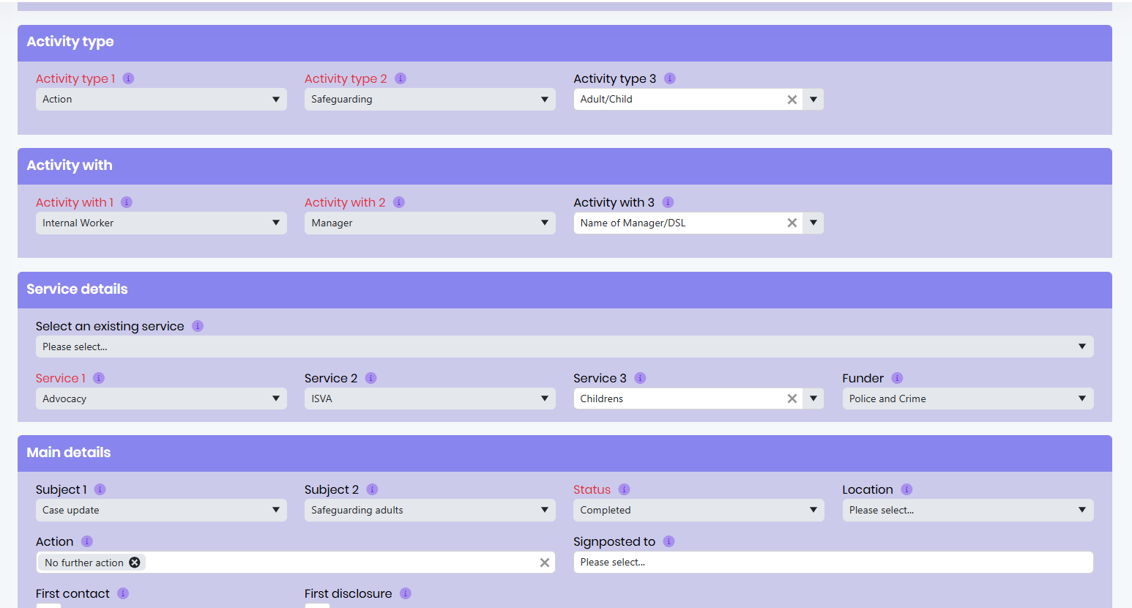

6.0 Early Help Assessment
6.1 Some children may not be at risk of harm, or there may not be child welfare concerns, and therefore not all concerns about children result in a referral to Children’s Social Care. Some concerns lead to an acknowledgement that a family may need a range of supportive services to address additional needs (not child protection related). If this is the case, an early help assessment is usually used.
6.2 All ISVA’s and Counsellors should be aware of and adhere to RASASC’s Safeguarding Policy which provides Links to guidance to the different areas we cover.
6.3 Early Help Assessments (EHA)
The EHA is a tool where practitioners can identify a child's or young person's needs early, assess those needs holistically, deliver coordinated services and review progress. The EHA is designed to be used when:
- A practitioner is worried about how well a child or young person is progressing, for example concerns about their health, development, welfare, behaviour, progress in learning or any other aspect of their wellbeing refer to Appendix 13 for Every Child Matters Priority Outcomes
- a child or young person, or their parent/carer, raises a concern with a practitioner
- A child or young person's needs are unclear, or broader than the practitioner's service can address
The process is entirely voluntary and informed consent is mandatory, so families do not have to engage and if they do, they can choose what information they want to share. Children and families should not feel stigmatised by the EHA; indeed, they can ask for an EHA to be initiated.
The EHA process is not a 'referral' process but a 'request for services'.
The EHA should be offered to children who have additional needs to those being met by universal services. Unless a child is presenting a need, it is unlikely the EHA will be offered. The practitioner assesses needs using the EHA. The EHA is not a risk assessment.
If during the EHA process, a child or young person reveals they are at risk, the practitioner should follow the local safeguarding processes immediately, informing the safeguarding lead within their own organization.
6.4 EHA guidance for RASAC
When should EHA be used?
You can do an Early Help assessment at any time if you are worried about a child or young person’s progress without additional services. The EHA process has been designed to help practitioners assess needs at an early stage and then work with the child or young person and their family.
Please note:
- If you are worried about a child or young person, but not able to do an EHA yourself, refer this to your line manager or supervisor.

- The EHA is not for a child or young person about whom you have concerns that they might be suffering, or may be at risk of suffering, harm. In such instances, you should follow your Local Safeguarding Children Board (LSCB) safeguarding procedures without delay.
- and other practitioners and agencies to meet them. As such, it is designed for use when:
-You are worried about how well a child or young person is progressing. You might be worried about their health, development, welfare, behaviour, progress in learning or any other aspect of their well-being.
-A child or young person or their parent/ carer raise a concern with you
-The child or young person’s needs are unclear, or broader than your service can address.
- If you proceed with an early help assessment, you must:
-Obtain the informed consent of the child or young person and/or their parent/carer to undertake a common assessment and to record the information either on paper or electronically. This means that you must ensure that they fully understand the EHA process and its implications.
-obtain the explicit consent of the child or young person and/or their parent/ carer to share the EHA information with other practitioners (i.e. specify explicitly which services are included or excluded in the consent)
-Formally record what services the consent applies to and/or any limits to the consent

7.0 Roles and responsibilities:

7.1 Designated Safeguarding Leads

- Hold ultimately accountability and responsibility for concerns highlighted to them.
- Make final decisions on disclosure.
- Support the worker to establish whether a service user is at significant risk of harm.
- If risk is identified support the worker to take appropriate action
- Maintain links with relevant external services.
- Follow up relevant cases with workers and review regularly.
- To ensure policies and procedures are reviewed bi-annually.
- Encourage safeguarding discussion in supervision.

Contact information for all Designated Safeguarding Leads:

Heather Cooper: Safeguarding Officer 07943 495 173
Jaswere Kaur Bruce: Safeguarding officer 07494 795 192
Heather Collington: Safeguarding Officer 07983 628 227
Emma Goldsworthy: Safeguarding Officer 07983 627 943
Ania Conboy: Safeguarding Officer 07904 269 479
Immy Stopps: Safeguarding Officer 07538 393 768
Ashleigh Parsons: Safeguarding Officer 07904 269 655

7.2 Workers

- Workers must inform the designated officer of all cases of young people (18 and under) and adults at risk regardless of concerns
- Workers must complete mandatory safeguarding training; this must be refreshed every 3 years
- Must be competent in understanding local safeguarding procedures and referral pathways.
- Workers must be competent in using their own judgement to make a safeguarding referral as appropriate and within a timely manner.
- In circumstances where safeguarding actions are unclear the worker must liaise with a manager to establish the most appropriate course of action
- Workers must inform the designated officer following a safeguarding referral through submission of a Safeguarding Incident Report form.
- In the first instance, the worker must remind the service-user of the safeguarding statement and advise them that they are obliged to report the risk
- It is the responsibility of the worker to talk through with the service-user every possible course of action so that both parties understand the implications
- If the service-user is doubtful about reporting a significant harm risk, the worker must advise that they are obligated as a worker to report that danger
- Support the service user.
- Review with management regularly once safeguarding concerns have been raised.
- Workers will engage with all levels of the safeguarding process this will include attending meetings and sharing information as appropriate

8.0 If a child or adult does not engage.

In all cases where a child or does not engage with our service the case will be brought to the relevant manager’s attention with a view to decide on informing the referrer and any other relevant third parties where necessary to ensure safeguarding (see appendix 5). This will be dealt with on a case-by-case basis.

9.0 Where there is a difference of opinion.

All concerns will be discussed between the worker, designated officer and (where appropriate) service user. Where there is a difference of opinion regarding a safeguarding concern the equivalent cover designated officer will be consulted. If a consensus cannot be reached, then the Board Of Trustees makes the final decision however a worker may use the whistle blowing policy to report serious concerns about decision making if needed or a service user may make a complaint.

10.0 Special consideration

Special consideration should be given to service users who have needs that may be a barrier to accessing support. Such as:

- People whose first language is not English.
- People who have a physical or learning disability
- People who are experiencing mental health issues

(This list is for example purposes only & is not an exhaustive list of special considerations)

11.0 Creating a Safer Culture

11.1 Harm minimised at Recruitment stage (see Staff Recruitment Policy)

2.1.1 We will undertake an enhanced DBS check all workers.
2.1.2 We will gain two references one of which refers to any work carried out with children or adults at risk
2.1.3 We will challenge and explore all workers on relevant attitudes at recruitment and throughout their training and professional development
2.1.4 All our workers must undergo a six-month probationary period under appropriate supervision
2.1.5 We will state our commitment to safeguarding children and adults at risk in all job adverts
2.1.6 All Job Descriptions and Person Specifications will contain reference to the Safeguarding role and responsibilities of RASASC and individual employees
2.1.7 A full employment history will be obtained for new staff (see Recruitment policy if applicants have gaps in employment history)

11.2 Training

All staff will receive an induction and ongoing training in line with RASAC’s training and recruitment policy. Safeguarding training must be completed annually by all staff, volunteers, and trustees, with records maintained by the senior team. The senior team will review all staff training and ensure refresher training is given within appropriate time periods.

11.3 Supervision

Regular line management supervision will be given to all ISVAs and counsellors as well as therapeutic supervision. Safeguarding concerns (past and present) should be openly discussed within line management supervision and should be brought as a topic to visit each session.

11.4 Managing allegations against people who work with children and young people

11.4.1 This section sets out the specific requirements as per Working Together to Safeguard Children (2018) that apply to managing allegations against staff or volunteers who work with children. The range of allegations which are covered under this section of the policy are not limited to those in which there is reasonable cause to believe a child is suffering, or is likely to suffer, significant harm. Allegations may also indicate that the staff member is unsuitable to continue to work with children in his or her present position, or in any capacity. Allegations against adults procedures should be instigated in all cases where it is alleged that a member of RASAC staff or volunteer has:

- behaved in a way that has harmed, or may have harmed a child;
- possibly committed a criminal offence against, or related to, a child;
- behaved towards a child or children in a way that indicates s/he is unsuitable to work with children.

11.4.2 Any investigation may consider the following three elements:
- a child protection investigation.
- circumstances which may require a police officer investigation.
- disciplinary procedures.
Where a member of staff has concerns about a colleague, they should inform the Chief Executive immediately.
Within each local authority there will also be a Local Authority Designated Officer (LADO) who has responsibility for providing advice and liaison and monitoring the progress of cases, to ensure that cases are dealt with as quickly as possible, consistent with a fair and thorough process. The Senior Manager, or in their absence/where the allegation relates to them, named senior managers should consult the LADO directly.

11.5 Adverse Incidents

All serious untoward incidents (SUI) (circumstances/incidents which have compromised the safety and welfare of children) should be reported to the paediatric lead for safeguarding children for the appropriate area, if applicable.

Appendices

Appendix 1 - Legislative and Professional Obligations

- Children are protected by a comprehensive framework of powers and responsibilities set out in the Children Act 1989 , its associated regulations and inter-agency guidance, Working Together to Safeguard Children, 2018 ; The Framework for the Assessment of Children in Need and their Families, 2000 working together with the Sexual Offences Act, 2003
- The Sexual Offences Act, 2003 (see above) Sections 45-60, addresses the issue of sexual exploitation of children through child sexual exploitation, images of child abuse, trafficking and grooming. Section 74 defines consent as “a person consents if he agrees by choice and has the freedom and capacity to make that choice”, making clear that submission is not consent. Sections 5-8 provide for several offences specifically designed to protect children under 13 and make clear that sexual activity with a child under 13 is never acceptable.
- RASAC has a duty to safeguard and promote the welfare of children under s11 of Children’s Act 2004⁶.

Appendix 2 - Gillick and Fraser guidelines

Gillick competency and Fraser guidelines refer to a legal case which looked specifically at whether doctors should be able to give contraceptive advice or treatment to under 16-year-olds without parental consent. Since then, they have been more widely used to help assess whether a child has the maturity to make their own decisions and to understand the implications of those decisions.
Young people under 16 have a right to confidential medical advice and treatment if the provider assesses that the young person:
- understands the advice and has the maturity to understand what is involved
- their physical/mental health will suffer if they do not have treatment
- it is in their best interest to give such advice and treatment without parental consent
- will continue to put themselves at risk of harm if they do not have advice and treatment
- cannot be persuaded by the doctor or health professional to inform parental responsibility holders, nor allow the doctor to inform them

The following should be used as guidance for practitioners in determining and recording their decision as to whether a young person is able to engage with RASAC ISVA or counselling service without the involvement and support from their parent(s) / carer(s).
- Has the young person explicitly requested that you do not tell their parents/carers about their involvement with RASAC?
- Have you done everything you can to support the young person to involve their parents/carers?
- Have you documented clearly why the young person does not want you to inform their parents/carers?
- Can the young person understand the advice and information they have been given and have sufficient maturity to understand what is involved in their service provision and what the implications may be? Can they comprehend and retain information relating to the care they are being offered? Can the young person communicate their reasons for any decisions made, are these decisions rational?
- Are you confident that the young person is making the decision for them and not being coerced or influenced by another person?
- Are you confident that you are safeguarding and promoting the welfare of the young person?
- Without the service being provided would the young person’s physical or emotional health be likely to suffer?
- Would the young persons’ best interests require that support be provided without parental consent?

You should be able to answer YES to these questions to enable you to determine that you believe the young person is competent to make their own decisions about consenting to engage with RASAC; limits to confidentiality; and receiving services without their parent’s consent. You should record the details of your decision making.

Appendix 3 - Definition of abuse
There are four types of child abuse. They are defined in the UK Government guidance Working Together to Safeguard Children 2015 (Appendix A) as follows:
Physical Abuse: A form of abuse which may involve hitting, shaking, throwing, poisoning, burning or scalding, drowning, suffocating or otherwise causing physical harm to a child. Physical harm may also be caused when a parent or carer fabricates the symptoms of, or deliberately induces, illness in a child.

Sexual Abuse: Involves forcing or enticing a child or young person to take part in sexual activities, not necessarily involving a high level of violence, whether or not the child is aware of what is happening. The activities may involve physical contact, including assault by penetration (for example, rape or oral sex) or non-penetrative acts such as masturbation, kissing, rubbing and touching outside of clothing. They may also include non-contact activities, such as involving children in looking at, or in the production of, sexual images, watching sexual activities, encouraging children to behave in sexually inappropriate ways, or grooming a child in preparation for abuse (including via the internet). Sexual abuse is not solely perpetrated by adult males. Women can also commit acts of sexual abuse, as can other children.

Neglect: The persistent failure to meet a child’s basic physical and/or psychological needs, likely to result in the serious impairment of the child’s health or development. Neglect may occur during pregnancy as a result of maternal substance abuse. Once a child is born, neglect may involve a parent or carer failing to:
• provide adequate food, clothing and shelter (including exclusion from home or abandonment).
• protect a child from physical and emotional harm or danger.
• ensure adequate supervision (including the use of inadequate caregivers); or
• ensure access to appropriate medical care or treatment.
It may also include neglect of, or unresponsiveness to, a child’s basic emotional needs.
Emotional Abuse: The persistent emotional maltreatment of a child such as to cause severe and persistent adverse effects on the child’s emotional development. It may involve conveying to a child that they are worthless or unloved, inadequate, or valued only insofar as they meet the needs of another person. It may include not giving the child opportunities to express their views, deliberately silencing them or ‘making fun’ of what they say or how they communicate. It may feature age or developmentally inappropriate expectations being imposed on children. These may include interactions that are beyond a child’s developmental capability, as well as overprotection and limitation of exploration and learning, or preventing the child participating in normal social interaction. It may involve seeing or hearing the ill-treatment of another. It may involve serious bullying (including cyber bullying), causing children frequently to feel frightened or in danger, or the exploitation or corruption of children. Some level of emotional abuse is involved in all types of maltreatment of a child, though it may occur alone.

Sexual exploitation: The sexual exploitation of children and young people is a form of child sexual abuse.
Safeguarding Children and Young People from Sexual Exploitation (2009) describes sexual abuse as follows:

Sexual exploitation of children and young people under 18 involves exploitative situations, contexts and relationships where young people (or a third person or persons) receive ‘something’ (e.g., food, accommodation, drugs, alcohol, cigarettes, affection, gifts, money) as a result of them performing, and/or another or others performing on them, sexual activities.

Child sexual exploitation can occur through the use of technology without the child’s immediate recognition; for example, being persuaded to post sexual images on the Internet/mobile phones without immediate payment or gain. In all cases, those exploiting the child/young person have power over them by virtue of their age, gender, intellect, physical strength and/or economic or other resources.

Violence, coercion and intimidation are common, involvement in exploitative relationships being characterised in the main by the child or young person’s limited availability of choice resulting from their social/economic and/or emotional vulnerability.

Appendix 4: Possible Outcomes

What will happen once the danger is reported? (See Working Together 2015 for more information)

- A Strategy Discussion/Meeting involving Children’s Social Care, Police and any other relevant agency working with the child/family will take place as appropriate.
- Purpose of Strategy Discussion/Strategy Meeting is to share information and plan (see below taken from Working Together to Safeguard Children 2015):
The discussion should be used to:
  - share available information
  - agree the conduct and timing of any criminal investigation
  - decide whether section 47 enquiries should be initiated and therefore a core assessment be undertaken under section 47 of the Children Act 1989, or continued if it had already begun under section 18 of the Children Act 1989
  - plan how the section 47 enquiry should be undertaken (if one is to be initiated) including the need for medical treatment and who will carry out what actions, by when and for what purpose
  - agree what action is required immediately to safeguard and promote the welfare of the child, and/or provide interim services and support. If the child is in hospital decisions should also be made about how to secure the safe discharge of the child
  - determine what information from the strategy discussion will be shared with the family unless such information sharing may place a child at increased risk of suffering significant harm or jeopardise police investigations into any alleged offence(s); and
  - determine if legal action is required.

- Relevant matters will include:
- agreeing a plan for how the core assessment under section 47 of the Children Act 1989 will be carried out – what further information is required about the child(ren) and family and how it should be obtained and recorded.
- agreeing who should be interviewed, by whom, for what purpose and when. The way in which interviews are conducted can play a significant part in minimising any distress caused to children and increase the likelihood of maintaining constructive working relationships with families. When a criminal offence may have been committed against a child, the timing and handling of interviews with victims, their families and witnesses can have important implications for the collection and preservation of evidence.
- agreeing, in particular, when the child will be seen alone (unless to do so would be inappropriate for the child) by the lead social worker during the course of these enquiries and the methods by which the child’s wishes and feelings will be ascertained so that they can be considered when making decisions under section 47 of the Children Act 1989.
- race and ethnicity of the child and family, considering how these should be considered and establishing whether an interpreter will be required; and
-considering the needs of other children who may be affected – for example, siblings and other children, such as those living in the same establishment – in contact with alleged abusers.
An initial Child Protection Conference will decide whether the child should become subject to Child Protection Plan and if so an agreed outline of the Plan will take place.

Appendix 5 - Referral (Child Social Care)

Before making a referral:
- What are your specific concerns?
- Have you any factual evidence to support your concerns?
- What, if anything has the child said or done to increase your concerns?
- What, if anything has the parent/carer said or done to increase your concerns?
- Have you discussed concerns with manager / supervisor?
- Do colleagues share your concerns?
- Have you made a written record of your concerns?
- Have you discussed your concerns with any other professionals?
- Have you told whoever is reporting of your intention to share concerns with social services?
- What was their response?
- Are you clear about what you are asking social services to do?
  - Provide you with advice/information.
  - Re-direct you to other services which may help the family.
  - Investigate a child protection concern.
  - Complete an assessment on the family.

Please note: Each LSCB has its own referral process and form to be completed; these are accessed through a discussion by telephone with the child social care team who will establish as to whether the referral criteria has been met and will provide details of the correct form to use.

Appendix 6 - RASAC Safeguarding Concerns Log

Please use this form to report any safeguarding incidents or concerns. It should be completed by the worker who has been disclosed to, who witnessed the incident, was most directly involved or who provided first aid if relevant. Please use the risk assessment alongside this form to help you asses the level risk

Name & role of person completing this form:

Service i.e. ISVA/Therapy/Group
Name of RASAC DSL:
Service:

Details of child, young person or adult at risk:
Name: | Address:
Contact number: | Gender:
Date of birth: | Age:
Any further information:

Parents/carers details:
Name: | Address:
Contact number: | Email address:
Have parents/carers been notified of the incident?  Yes ☐  No ☐ | If yes, please provide details:

Details of the person reporting:
Are you reporting your own concerns, or responding to concerns raised by someone else? If responding to someone else’s concerns, please provide their details
Name:
Relationship to child, young person or adult at risk:
Email:
Contact number:

Incident Details:
Incident Date:

Location of Incident:

Type of incident (e.g. self-harm, suicidal ideation, HBV):

Description of the incident or concern:
(Include relevant information such as what happened and how it happened, description of any injuries sustained, behaviour witnessed and whether the information provided is being recorded as fact, opinion or hearsay)

Details of any previous concerns, incidents or relevant safeguarding records:

Child, young person or adult at risk, account of the incident or concern: (use their own words)

Details of any witnesses? Name and contact and relationship to client where possible:

Details of any persons involved in the incident or alleged to have caused the incident, injury or presenting risk:

Outcome of incident & actions taken (please number the actions):

External agency referral:
Agency | Date and time reported | Name of contact Person | Contact no/email | Action agreed or given

Follow-up action required:
Action: | Due date: | Whom responsible:

Reporting to the Designated Safeguarding Lead (DSL)

Name of RASAC DSL:

Date & time DSL notified of incident/concern:

DSL comments: (advice given/ actions taken / external agency involvement / lessons learned / follow-up actions)

Signed: | Name: | Date:
RASAC DSL Signed: | Name: | Oversight Date:

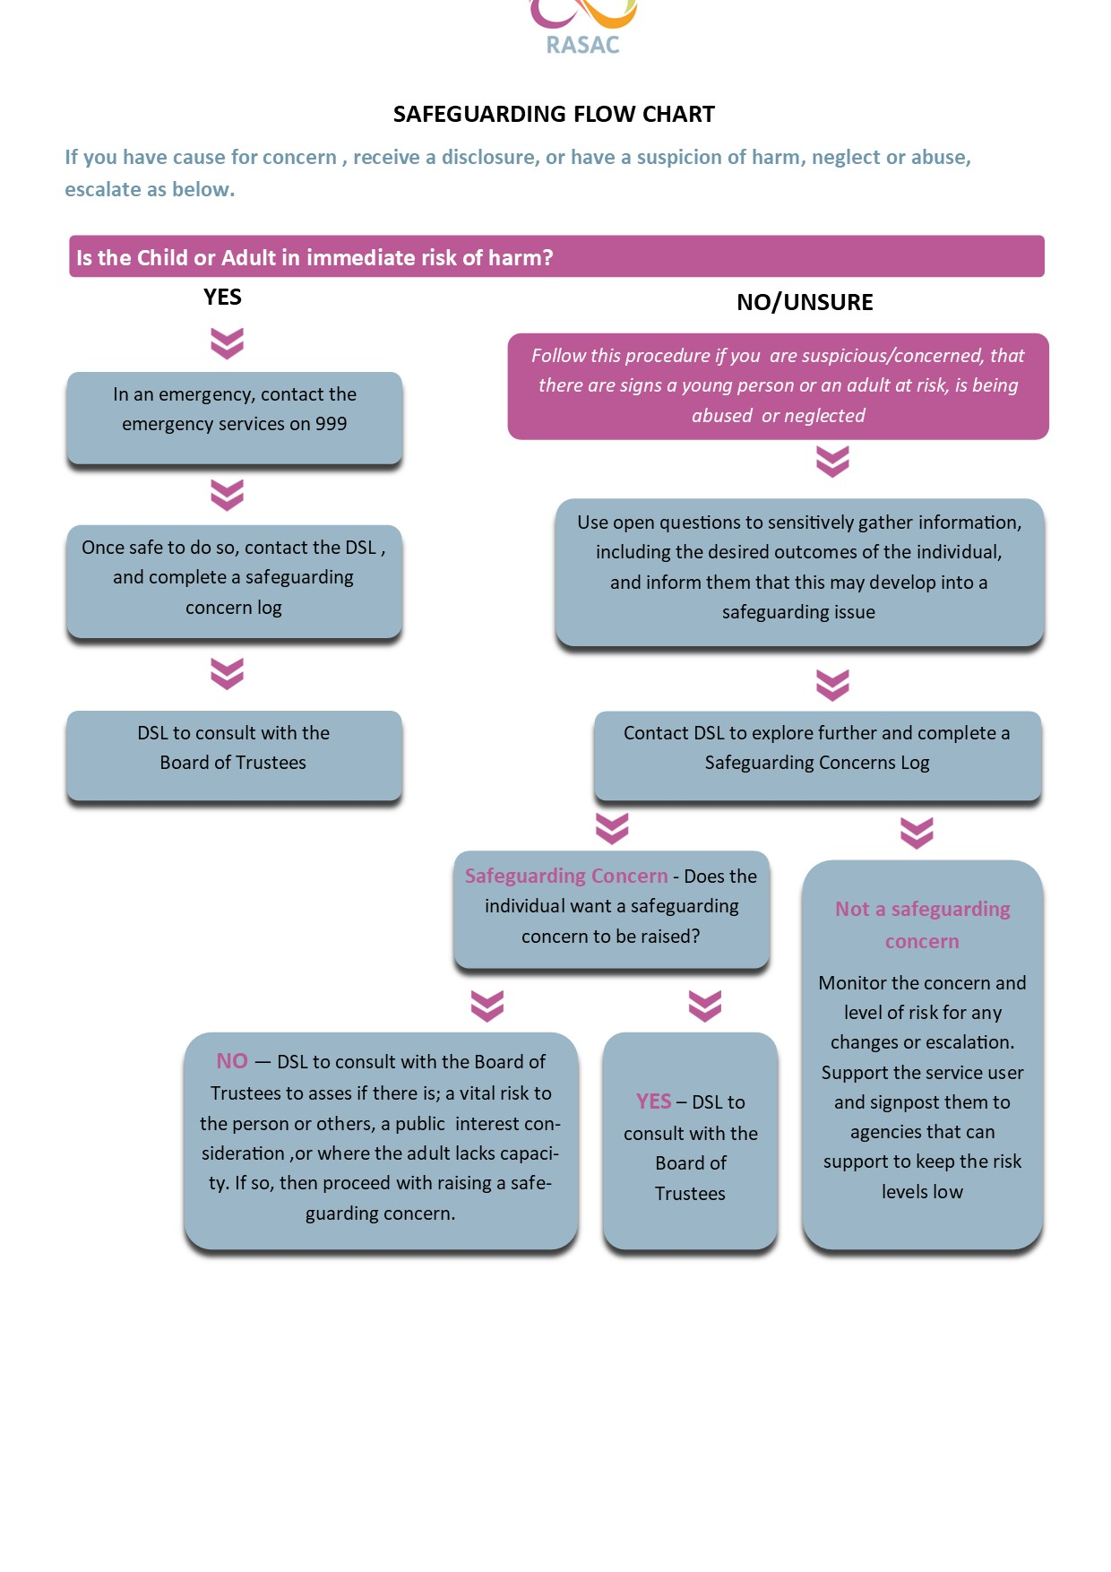

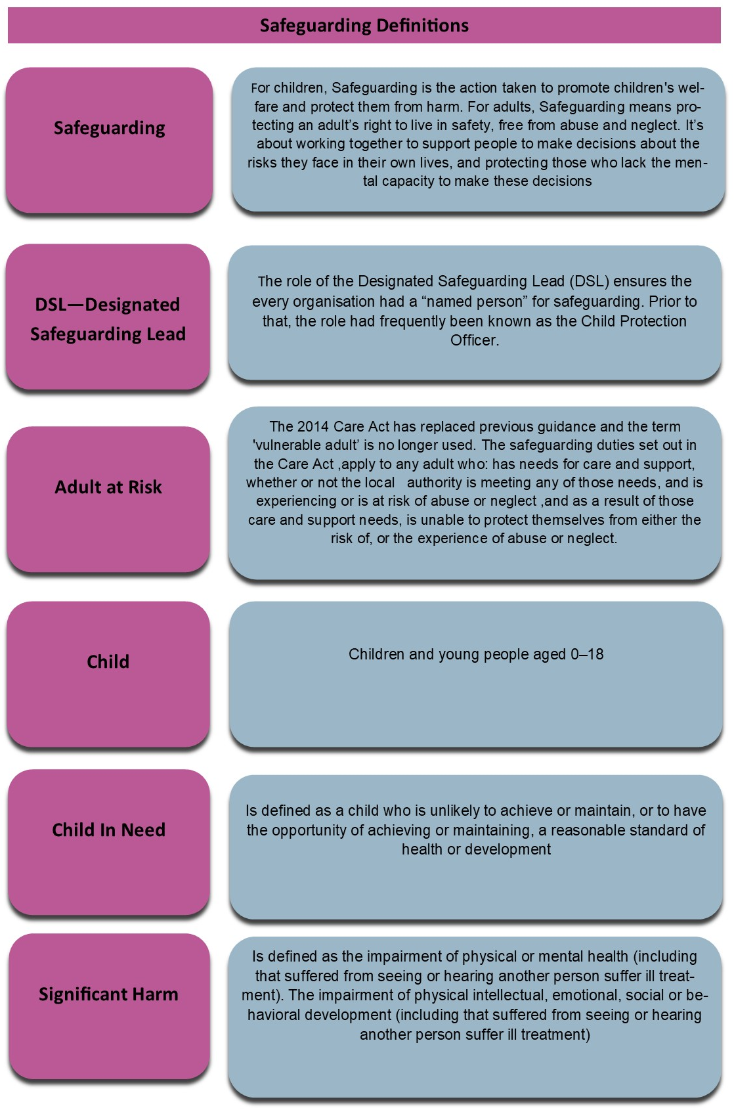

http://www.opsi.gov.uk/Acts/acts1989/Ukpga_19890041_en_1.htm
³Working Together to Safeguard Children 2018 (publishing.service.gov.uk)
http://www.opsi.gov.uk/Acts/acts2004/ukpga_20040031_en_1
http://www.opsi.gov.uk/Acts/acts2003/ukpga_20030042_en_1

