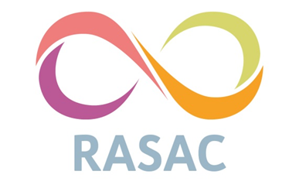
Equality and Diversity Monitoring Form

At Kirklees and Calderdale Rape and Sexual Abuse Centre (KCRASAC) we are committed to equality and actively seeking qualified candidates that contribute to the diversity of our organisation.

We are asking for the following information so that we can ensure that our recruitment and selection processes are free from discrimination. The data we are asking for reflects the Equality Act 2010 requirement not to discriminate on the grounds of; age, disability, ethnicity, marital/civil partnership status, religion and/or belief, sexual orientation and pregnancy and/or childbirth.

The information you provide will be treated confidentially within KCRASAC. As such, we ask that your Equal Opportunities Monitoring Form be completed and returned separately to your Application Form to ensure confidentiality. Your completed Equal Opportunities Monitoring Form should be returned via email to referrals@kcrasac.co.uk by the closing date.

Sex:
Male |  | Female |  | Prefer not to say

Sexuality:
Gay |  | Lesbian
Heterosexual |  | Bi-Sexual
Asexual |  | Prefer not to say

Gender Identity: Is your gender identity the same as the gender you were assigned at birth?

Yes |  | No |  | Prefer not to say

Marital / Civil Partnership Status: Are you married or in a civil partnership?
Yes |  | No |  | Prefer not to say

Age:
16 – 25 |  | 26 – 35 |  | 36 – 45 |  | 46 – 55 |  | 56 – 65 |  | 66+

Ethnicity:
How would you describe your ethnicity? Please choose one section from A to F and then tick the appropriate box.

A. White
English, Welsh, Scottish, Northern Irish, British
Irish
Gypsy or Irish Traveler
White other
B. Mixed / Multiple ethnic groups
White and Black Caribbean
White and Black African
White and Asian
Any other Mixed background
C. Asian or Asian British
Indian
Bangladeshi
Pakistani
Chinese
Any other Asian background
D. Black / African / Caribbean / Black British
Caribbean
African
Any other Black background
E. Other ethnic group
Arab
Any other ethnic background
F. Prefer not to say
Religion and Belief:
Buddhist
Christian
Hindu
Muslim
Jewish
Sikh
Other Religion or Belief
No Religion
Prefer not to say

Disability: The Equality Act 2010 defines disability as: “A physical or mental impairment which has a substantial and long-term adverse effect on a person's ability to carry out normal day-to-day activities.”
Do you consider yourself to be a disabled person?
Yes |  | No |  | Prefer not to say

We thank you very much for completing this Equal Opportunities Monitoring Form,
Please return to referrals@kcrasac.co.uk.

