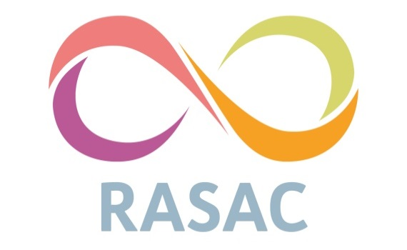

Kirklees, Calderdale, and Wakefield Rape & Sexual Abuse Counselling Centre
Volunteer Application Form

Position | Volunteer
Hours | Minimum Commitment of Three Hours per Week
Location | Kirklees, Calderdale, and Wakefield

Personal Details:
Name: | Date of Birth:
Address: | If successful, please provide the earliest date you could start volunteering?
Contact Number: | Email Address:

References:
Reference 1 | Referee’s Name:  Referee’s Position:  Address:  Relationship to Applicant:  Contact Details:  May we contact this referee prior to your interview:
Reference 2 | Referee’s Name:  Referee’s Position:  Address:  Relationship to Applicant:  Contact Details:  May we contact this referee prior to your interview:

Qualifications: If you have this information, in full, in CV a format, you may replace this table with your own version.
Establishment | Dates: | Course attended and/or qualification gained:

Training Courses and Personal Development: If you have this information, in full, in CV a format, you may replace this table with your own version.
Course Title and Organising Body | Dates: | Brief description of knowledge/skill gained:

Application Questions: Please answer the below questions as wholly as possible, using examples from your knowledge and experience.
Question | Answer
What is it that interests you about volunteering for our organisation?
What do you think you can offer us at the centre (life experience; work experience; skills and personal qualities etc?)
What is your understanding of rape, sexual and domestic violence?
What is your understanding of empathy?
We offer support and counselling services to survivors over the age of 13 years old regardless of race; physical ability; sexuality; culture; class and social background. What are your thoughts and feelings about this statement?

Although we predominantly work with females over 13 years old; we also work with males who are survivors of rape, sexual and domestic abuse. What are your thoughts about working with males?

Briefly explain your understanding of Equal Opportunities.
We are a feminist organisation therefore work within a feminist framework. What are your thoughts and feelings about this?
Please use this space to identify to which of the following roles you are interested in; | - Helpline Support  - Administrative support  - Volunteer 1-to-1 Support Worker  - Supporting courses in schools around consent and healthy relationships  - Outreach; leafleting, running stalls and social media campaigns.

Reasonable Adjustments: Our selection process consists of this Application Form and an interview. Do you need any adjustments to be able to participate in this process? If so, please specify:

Criminal Offences and Safeguarding Children and Vulnerable Adults: The position you have applied for is exempt from the Rehabilitation of Offenders Act 1974 and is subject to a Disclosure and Barring Service (DBS) check. This means that you should provide information about all previous convictions, including those that are spent. Failure to disclose relevant information below could lead to RASAC withdrawing an offer of employment. The information you provide here will be kept confidential. The disclosure of a criminal record will not necessarily prevent your employment with RASAC. In making our decision, we will carefully consider any conviction’s relevance to the appointment.

Have you at any time been convicted of a criminal offence? Yes / No

Have you been restricted from working with children or vulnerable adults? Yes / No

If the answer to either or both questions is ‘yes’, please give details:

Emergency Contact Details
Emergency contact name:  Emergency contact relationship to me:  Emergency contact phone number: | Do you have any health conditions we should be aware of?  Do you have any medication that we would need to administer in case of emergency?  Do you carry this medication with you at all times?

Declaration:
“I declare that the information that I have given throughout this application is correct to the best of my knowledge”
Note: The withholding, falsification, or omission of relevant information by a successful candidate is grounds for disciplinary action being taken.
Signed: | Date:

Please note: All potential volunteers are required to attend an interview and undertake compulsory training before volunteering at the centre.

We thank you very much for completing this Application Form.
Please return to liv.dawson@rasac.co.uk

