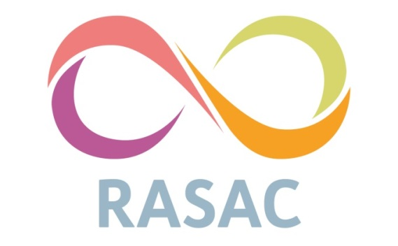
Volunteer Application Pack
Dear Applicant,
Thank you very much for your interest in volunteering at Kirklees, Calderdale and Wakefield Rape and Sexual Abuse Centre. Our volunteers are integral to the work that we do and the service we provide for people who have experienced rape and sexual violence.
This pack gives you information about who we are, what is involved in volunteering at RASAC about our Volunteer Induction Training Course. This Application Pack includes the following.
- Information for Applicants
- About RASAC
- What do Helpline Volunteers do?
- What qualifications or experience do I need?
- Training
- Disclosure Barring Service
If you are interested in applying for this position, please download our Application Pack, the Application Form and the Equal Opportunities Monitoring Form and read in full.
Our selection process consists of the Application Form and an interview. If you require any adjustments to be able to participate in this process, please do let us know and we will endeavour to accommodate. Unfortunately, on this occasion we will be unable to respond to all applications that are not shortlisted. Should you not hear from us within two weeks of the closing date, please assume that on this occasion your application has been unsuccessful.
RASAC is committed to equality and to actively seeking qualified candidates that contribute to the diversity of the organisation. As such, we ask that our Equal Opportunities Monitoring Form be completed and returned separately to your Application Form to ensure confidentiality. Your completed Equal Opportunities Monitoring Form should be returned via email to anything@rasac.co.uk by the closing date.
Your completed Application Form should be returned via email to liv.dawson@rasac.co.uk by the closing date.
Please feel free to ask if you have any questions.
Warm regards,
Liv Dawson, Therapeutic Team Operations Lead

About RASAC
RASAC have been delivering support to people who have experienced rape, domestic and sexual violence since 1989. As an approved member of Rape Crisis England and Wales, our organisation aims to: provide services for people who have experienced rape and sexual violence; contribute to ending rape and sexual violence against people and redress the gender and structural inequities that limit people’s lives. Presently, RASAC offers the three below services across the Kirklees, Calderdale, and Wakefield areas.
Therapeutic Services: All our workers are trained and skilled in working with issues of sexual and domestic violence. Through offering a wide range of therapies, including Counselling, Art Therapy, Group Therapy and Reiki, our Counsellors offer people a safe space in which to explore their thoughts, feelings, and behaviours.
Independent Sexual Violence Advisors (ISVA): Our Independent Sexual Violence Advisor’s offer confidential advice and support to people who have experienced sexual violence. They will support people come to terms with what has happened and explain the options available to them.
Helpline: Our Helpline offers confidential, anonymous emotional support and information to survivors of rape, sexual abuse, and domestic violence via, telephone, text, webchat, and email.
Support work: Our RASAC Support Workers offer practical and emotional support to survivors of rape, sexual and domestic abuse.
As a feminist organisation our principles of equal opportunities ensure that we offer a non-judgemental service. We recognise that any form of sexual and domestic violence takes place where one person(s) assumes power and control over another; with no regard to the impact of their actions. We believe that if individuals are given the information and support to take control of their own life, this will increase their confidence. By doing this it will encourage positive changes within their life and increase their self-esteem.
For more information about RASAC please visit http://www.rasac.co.uk

What do Volunteers do?
RASAC volunteers typically cover one (3 hour) shift a week providing support and information for people who have experienced rape and sexual violence via telephone, email, and webchat. In addition to providing our frontline service, volunteers are also required to complete a small amount of admin on each shift. Equally, volunteers here at RASAC can also go on to support our school’s worker providing education in schools around consent and healthy relationships, or offer one-to-one support for survivors. All volunteers will have the opportunity to engage with ongoing training and development throughout their time at RASAC and other opportunities as they arise.

What Experience do I Need?
You don’t need any special qualifications or experience to become a Helpline Volunteer. However, there are a few basic requirements that all Helpline Volunteer’s need to meet to be able to carry out the work:
- Over the age of 18.
- Have basic literacy and numeracy - spelling and/or grammar are not important, but you must be able to read and write in English.
- Have a good level of English and be able to make yourself understood, as well as understand spoken English.
- Have access to a mobile, laptop, earphones with a microphone, reliable internet access and a quiet/private room where you will not be disturbed if you are training or volunteering remotely.
- Be available to do one regular 3 hour shift each week

If you have any specific access needs that you wish to discuss with us prior to application, please feel free to contact us.

Training
Below is the training timetable for our Autumn 2026 recruitment of volunteers. This training will be held in person, in our Huddersfield office (town centre). All the sessions are important and build on each other as we progress through the weeks. For this reason, we ask that volunteers attend all sessions. If you are unable to commit to attending at least 90% of the training programme, we might not be able to accept your application this time but encourage you to apply during the next recruitment period. Please indicate on your application form whether you are able to make each session of the training programme.

Week | Date | Time | Topic
Session 1 | 02/10/26 | 10:00am – 16:00pm | Feminism & Oppression
Session 2 | 09/10/26 | 10:00am – 16:00pm | Sexual Violence
Session 3 | 16/10/26 | 10:00am – 16:00pm | Domestic Violence
Session 4 | 23/10/26 | 10:00am – 16:00pm | Trauma Responses
Session 5 | 30/10/26 | 10:00am – 16:00pm | Coping Strategies
Session 6 | 06/11/26 | 10:00am – 16:00pm | Barriers & Support Skills
Session 7 | 13/11/26 | 10:00am – 16:00pm | Skills Practice & DPMS

Disclosure Barring Service
All volunteers are required to have an enhanced Disclosure Barring Service (DBS) check due to the nature of the service we provide. Everyone who applies to be a volunteer will be asked to disclose if they have a criminal record or not. Please note if you do disclose a criminal record, we will treat this information in line with our confidentiality policy. If you’d like to talk to us about your past convictions before applying, please email to the email address given at the end of this booklet.

Contact Us
If you have any additional questions, please contact us via email – anything@rasac.co.uk Phone – 0300 303 4787.

We thank you very much for reading this Application Pack. If you are interested in applying for this position, please download our Application Form and complete and return in full to liv.dawson@rasac.co.uk and Equal Opportunities Monitoring Form, complete and return in full to anything@rasac.co.uk

